Thomas Russell Junior School

Friday 27th March 2020
9 – 9.30am | ‘PE with Joe’  Start the day with some action!  A 30 minute workout with Joe Wicks on YouTube.
9.30 – 11am | Have a go at one of your spag.com tasks or an English task out of your home learning pack.
11.15 – 12.15pm | 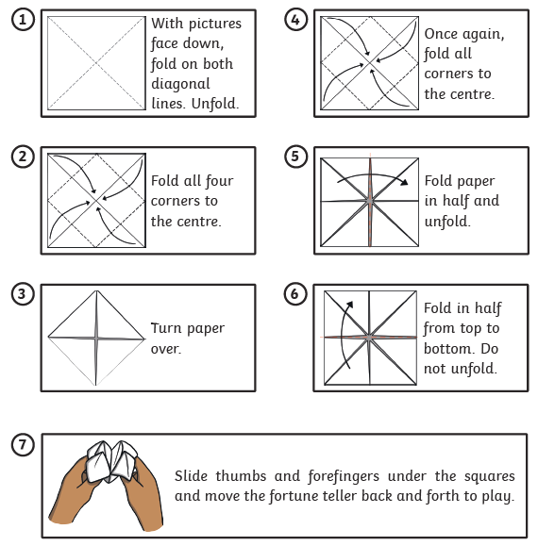  Make a fortune teller for the four operations: multiplication, division, subtraction and addition.  e.g. addition 732 + 819 1551
Lunchtime! | Turn your plate of food into an emoji! :) :( ;) :o :/
1.15 – 2.15pm | Get ready for some messy fun! Follow the instructions for making a loo roll bird feeder. You can make this simple feeder with items you probably already have at home:  - Smother a cardboard tube in peanut butter (no added salt and sugar versions are suitable for birds).  - Roll it in bird seed and thread some string through the hole.  - Tie it up in your garden where birds will feel safe eating.  How many garden birds will you spot? Take a look at the blog on woodlandtrust.org.uk/blog/2019/03/10-garden-birds/ to help you identify them.
2.30 – 3.30pm | Daily Wellbeing:  Have a go at illustrating our new TRJS Mindful Mantra. (See yesterday’s newsletter).  Send your pictures to skerrdelworth@thomasrussell-junior.staffs.sch.uk

