Thomas Russell Junior School

Tuesday 31st March 2020
9 – 9.30am | ‘PE with Joe’  Start the day with some action!  A 30 minute workout with Joe Wicks on YouTube.
9.30 – 11am | Go to pobble365.com/the-tunnel/.  Look at the picture:  Where could the tunnel lead?  Why is it there?  Who created it?  What is it made of?  How might it be used?  Write your own short story based on this picture. Think about the structure and try to include key story features to make it exciting for the reader. Will you write an adventure, a mystery, a romance, a fantasy, a ghost story…?  Every day on this website there is a new picture. You may like to choose a different picture – just scroll left and right through the pictures until you find one that inspires you!
11.15 – 12.15pm | Try your choice of maths activity on myminimaths.co.uk/.  Try some of the Intelligent Questioning questions to apply your skills.  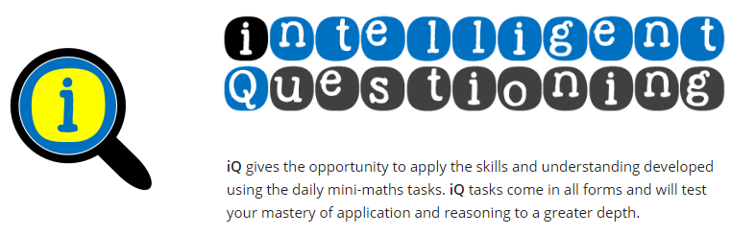
Lunchtime! | Have a go at eating mindfully. Take time to experience the taste of your food, what it feels like in your mouth, the temperature differences, the textures and smells.
1.15 – 2.15pm | Move like minibeasts  This is a great way to get active! You can do it outdoors or inside. Have a go at:  - lying on the ground and wriggle like a worm  - flapping your arms like a butterfly flutters its wings  - putting your hands on the floor and scuttle about like a spider  - doing some giant leaps like a cricket  - crawling on the floor then curling up into a ball like a woodlouse.
2.30 – 3.30pm | Do you know any Sign Language? Take a look at the alphabet below and try spelling out your name and the names of your family members.



