Thomas Russell Junior School

Tuesday 7th April 2020
9 – 9.30am | ‘PE with Joe’  Start the day with some action!  A 30 minute workout with Joe Wicks on YouTube.
- – 11am | Inky Pinkies are clues to a silly two word answer that rhymes. For example, a “meat stealer” is a “beef thief”, and a “complimentary oak” is a “free tree”. How many of these Spring-themed Inky Pinkies can you solve?  Twin rabbits Season ruler Daffodil building Bunny routine Posh Sheep Celebration Scoffer  Hat poem Fast bird Eccentric flower  Can you think of a Spring Inky Pinky of your own?
11.15 – 12.15pm | Get out your set of dominoes (if you don’t have a set, you can make your own or print out one such as printableboardgames.net/preview/Domino_Double-Six_Set)  There are many games and puzzles you can play with dominoes. This one is called ‘Windows’:  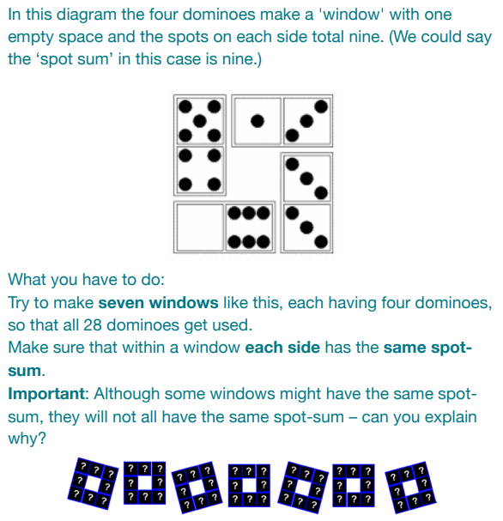  More domino games and puzzles can be found on: nrich.maths.org/1200
Lunchtime! | You may like to play a word-game while eating your lunch today. It could be an old favourite like I-spy or 20 questions, or a new game such as the lipogram game we suggested last week, or one-word-story where each person takes it in turn to say one word to make up a story. Where will your imagination take you today?
1.15 – 2.15pm | Lichfield Beacon Park Easter Trail  You may not be able to go to the park, but the park can come to you! To take part in the online Lichfield Beacon Park Easter Trail go to lichfieldhistoricparks.co.uk/eastertrail. Either look at the puzzles on your screen or ask an adult to print them out and make a trail around your house or garden. There are two sets of puzzles: a blue set for older children and a yellow set for younger children. Solve either or both sets of eight puzzles on your blue answer sheet or yellow answer sheet, collect the letters and see if you can work out which bees the Easter Bunny has already spotted in his garden this year. Email your answers to parks@lichfielddc.gov.uk and you’ll be entered in to the prize draw to win one of four family games. Good luck!  (Tomorrow is Beacon Park’s ‘Carrot Day’ with many carrot-based activities. Make sure you’ve got a few carrots in your house ready to take part!)
2.30 – 3.30pm | Daily Wellbeing  Take a look at the Childline website childline.org.uk/ for tips and reminders on what you can do to help yourself feel safe and happy while at home during the lockdown.  Childline’s number is 0800 1111 which you can call at any time. Remember to keep talking to adults at home about anything that is on your mind. We’ll see each other on the other side

