Thomas Russell Junior School

Tuesday 14th April 2020
9 – 9.30am | ‘PE with Joe’  Start the day with some action!  A 30 minute workout with Joe Wicks on YouTube.
- – 11am | Have fun recording yourself asking and answering questions. Use different sounds and voices, becoming an alien giving the weather in outer space or a squirrel covering nut collections in the yard! To get started, try using a tablet or phone app and use an audio recorder (e.g. in the GarageBand app).
11.15 – 12.15pm | Do you know what a tangram is?  Cut out these Easter Egg shapes then make pictures with the pieces:  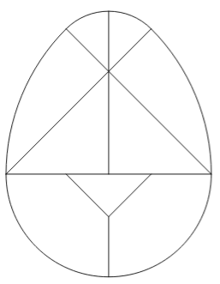  Example: 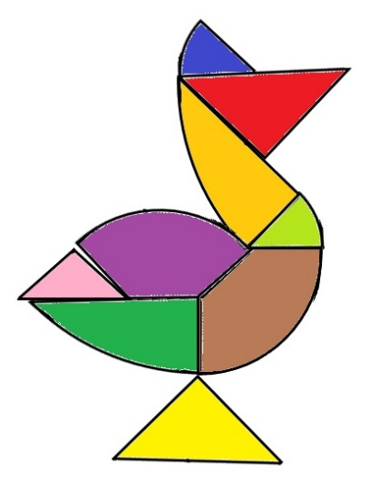
Lunchtime! | Imagine you are buying your lunch today. How much do you think each part would cost? What would be the total cost? Would you get from a £5 note?
1.15 – 2.15pm | Talk a trip to Northern Ireland and explore the Giant’s Causeway at nationaltrust.org.uk/giants-causeway/features/take-a-virtual-tour-of-the-giants-causeway  What do you notice about this spectacular landscape?  Is it like anywhere else you have visited?
2.30 – 3.30pm | Daily Wellbeing  Think about two role models in your life. Why do they inspire you?

