Thomas Russell Junior School

Wednesday 15th April 2020
9 – 9.30am | ‘PE with Joe’  Start the day with some action!  A 30 minute workout with Joe Wicks on YouTube.
9.30 – 11am | Ask an adult to read with you the story ‘My Hero is You’ (found in this folder). The author and illustrator Helen Patuck and the project team spoke to more than 1700 children, parents, caregivers and teachers from around the world about how they were coping with COVID-19. Their ideas helped her to write the story.  (Adults can find out more information by going to: unhcr.org/news/press/2020/4/5e8ecdba4/childrens-storybook-released-help-children-young-people-cope-covid-19.html It is a collaboration of the World Health Organisation (WHO), United Nations (UN) and national and international organisations who support mental health in emergency settings).
11.15 – 12.15pm | 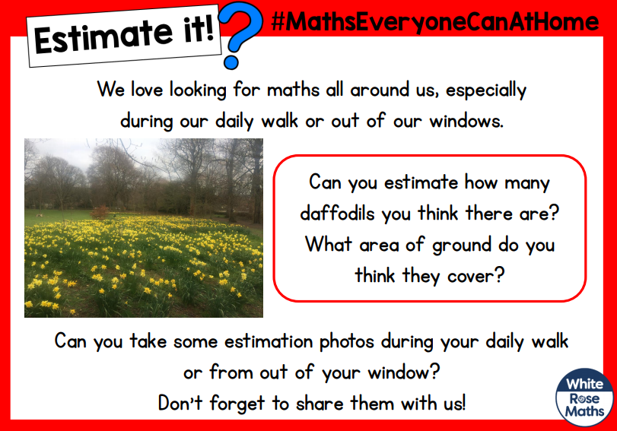We’d love to see your estimation photos and the maths you used to work out your estimations. Share it with us by emailing questions@thomasrussell-junior.staffs.sch.uk.  (There are more home-based maths puzzles at whiterosemaths.com/homelearning/easter-fun/)
Lunchtime! | As part of your lunchtime today, before you eat, you could do a 10 minute shake-up. Look at the ideas inspired by Disney at nhs.uk/change4life/activities/indoor-activities. Can you do some hippo hops with Pumbaa or throw some super shapes with Jack-Jack?!
1.15 – 2.15pm | Make a ball thrower  Research on the internet examples of levers in everyday life – for example, using a screwdriver to open a tin, or using a ball thrower for a dog. In the ball thrower example, you are using the lever to increase the distance that you can throw the ball. This will be today’s challenge. Can you use junk modelling or items you can find in your house to create a ball thrower? I would suggest using screwed up paper as a ball to avoid damaging things (and upsetting your family!). You could make it in an old cereal box and use a pencil as a pivot to secure your launcher. I am thinking of using elastic bands to power it. A plastic spoon would make a lovely ball thrower. Good luck!  There are more science make-and-do activities at rethinking-ed.org/science-activities-for-parents-primary/
2.30 – 3.30pm | Daily Wellbeing  Create a postcard for somewhere you have previously visited. What were your favourite memories of the place? Who might you address it too?

