Thomas Russell Junior School

Thursday 16th April 2020
9 – 9.30am | ‘PE with Joe’  Start the day with some action!  A 30 minute workout with Joe Wicks on YouTube.
- – 11am | Have a go at the Easter-themed wordsearch on thewordsearch.com/puzzle/261/easter/.  You can also make your own wordsearches on this website. Why not make one using the names of all the members of your class and email it to your teacher for her to have a go at?!
11.15 – 12.15pm | Have you ever stopped to marvel at just how many shapes there are in nature?  If you have a tablet, take a photo in your garden, then use a Markup app to trace all the shapes you can find in the photo. (Open your photo, tap Edit, then tap the three dots in the top-right to use Markup).  If you don’t have a tablet, try to copy the shapes you see exactly onto coloured paper then cut out the shapes to make a collage. We’d love to see what you can create. Send your photos to questions@thomasrussell-junior.staffs.sch.uk.  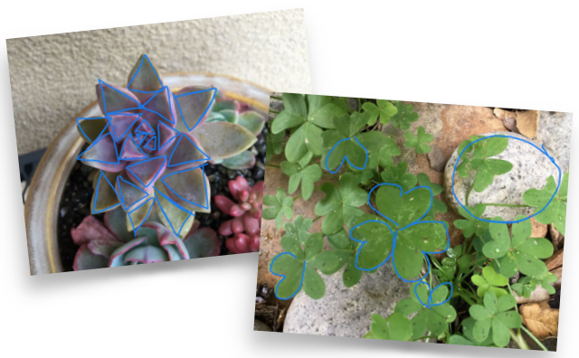
Lunchtime! | Think of alliterative adjectives to describe your lunch today e.g. tongue-tingling tomato, buttery bread, luscious lettuce…
1.15 – 2.15pm | Use the Thinkuknow website for an online safety activity. Adults can find guidance on these questions on the thinkuknow.co.uk website.  Activity 1: Alfie’s videos  Watch ‘Episode 1: Block Him Right Good, Alfie’ at www.thinkuknow.co.uk/8_10/watch/ .  Look at Resource Sheet 1: Alfie’s profile (below). Alfie has taken some important steps to make sure that he is safe when he is making videos and posting them online. Write down four steps Alfie has taken.  Activity 2: Being kind online  Let’s find out what you remember about Episode 1 of ‘Play Like Share’.  o Who wrote a mean comment about Alfie?  o Why wasn’t this a kind thing to do?  Remember that when we write or post something online, we must always think about how we might make other people feel.  o What positive words could Ellie, Alfie and Sam use to describe each other? Use Resource Sheet 2: Being kind online (below) to write as many positive words and phrases as you can think of next to each character, using any clues in the video to help.
2.30 – 3.30pm | Take a look at the artwork of Becky Bettesworth. Her website beckybettesworth.co.uk/collections/free-download-to-colour-in has six free colouring-in sheets for you to print and colour. If you cannot print at home, why not use her ideas as inspiration to make your own motivational poster. What could you draw to inspire others based on…?  - Dream Big  - Home Sweet Home  - Day Dreamer  - Happy Campers  - Love Keeps us Together  - Create your own Sunshine



