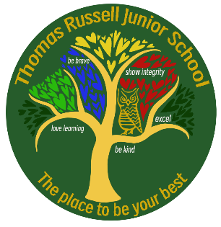
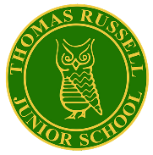
Thomas Russell Junior School
Year 6 Residential
Standon Bowers Day
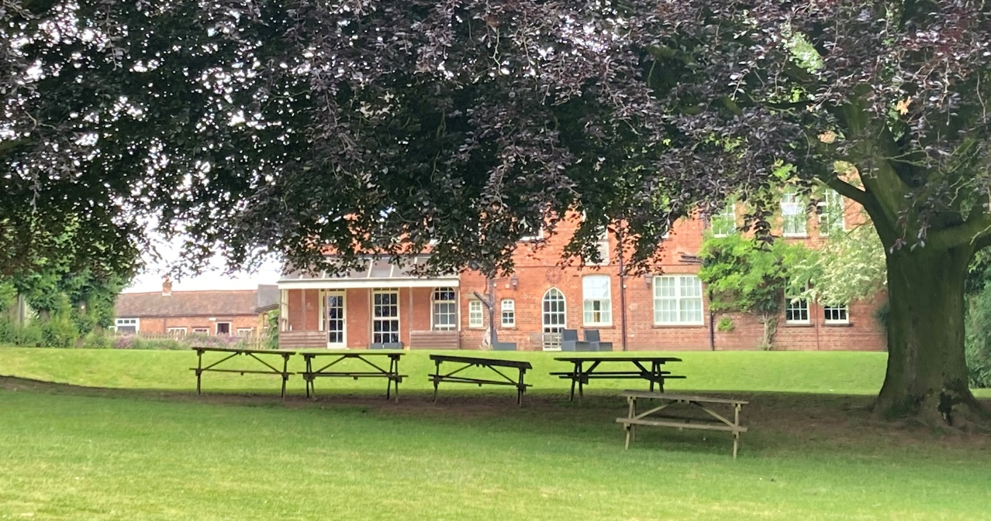

After a slightly delayed journey, we arrived safely at Standon Bowers. Set in beautiful countryside, it is a majestic, historic building that used to be a boarding school for boys until Staffordshire County Council purchased it for outdoor education. A perfect setting for a few days of exciting activities, self-discovery and teamwork.
The first task was making our beds, something that was achieved by everyone (well nearly everyone!). The sight of boys wrestling with fitted sheets was a thing to behold.
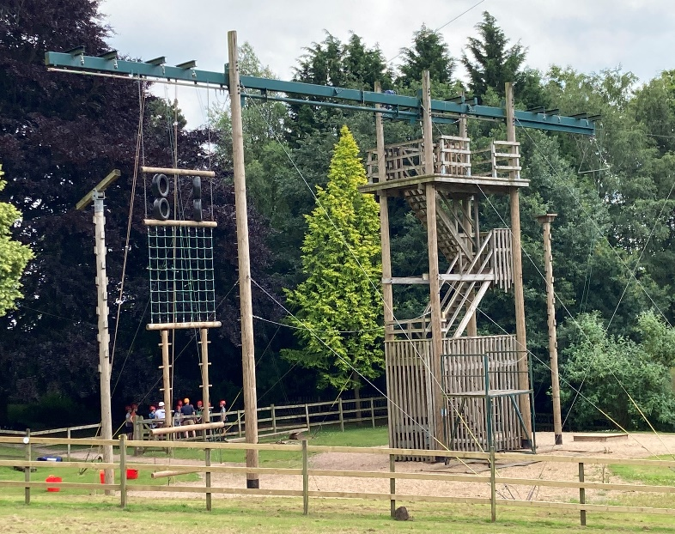
This afternoon, the children were put in 8 different activity groups with instructors leading the teaching and TRJS staff on hand to provide pastoral support. We had great fun with bushcraft, making fires and cooking marshmallows. Other groups engaged in team-building events called “The Crystal Maze” which involved getting your team from A to B on crates and getting a gold ball along gutters from the start to the finish. High Ropes was undertaken by the other groups and we witnessed amazing achievements with children pushing their limits and conquering any fear of heights.
Free time was enjoyed by all before tea, which was a roast dinner or jacket potato and cheese and beans. Suffice to say, there was not much left over!
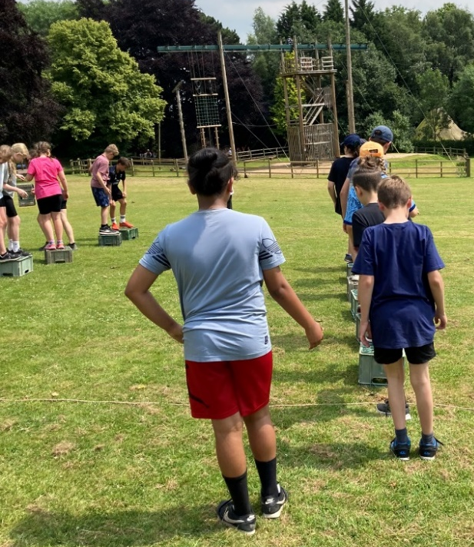
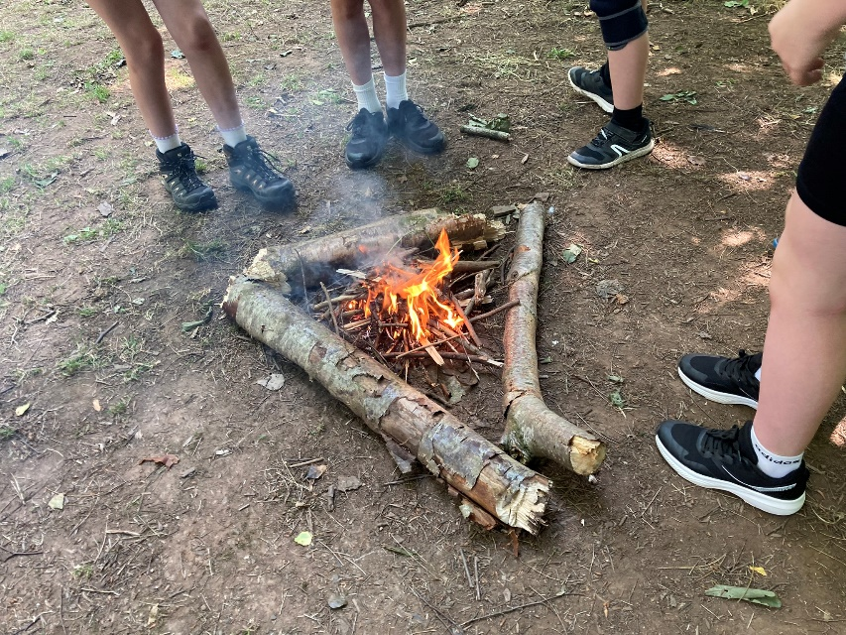
The evening activity involved working in teams to find photos around the site, followed by hot chocolate. After a day in the sun, Year 6 certainly needed showers (!) then after 9pm it was time to settle down. At the time of writing, Year 6 staff are supervising the children in their various dormitories and helping them to get off to sleep (here’s hoping!).

Day 1 in the Standon Bowers house has been brilliant. We have seen superb teamwork from all the groups, making memories that will last for many years. All are safe and well and looking forward to Day 2.

