

Thomas Russell Junior School
Year 6 Residential
Standon Bowers Day 2
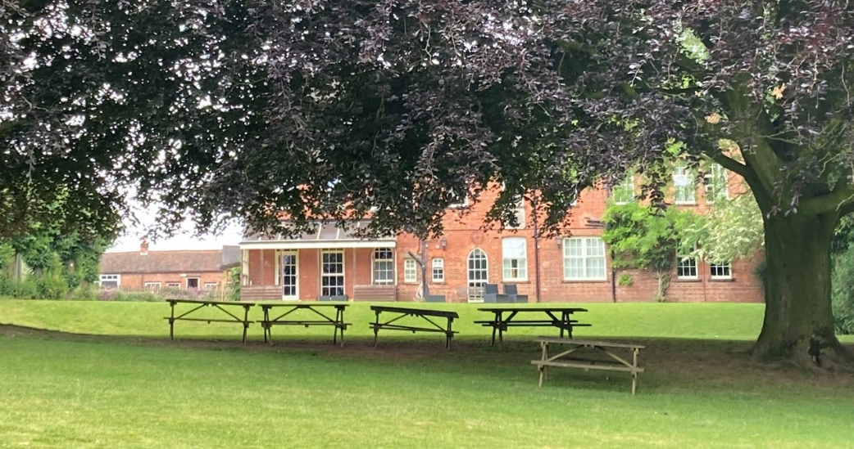

Well, sleep is very illusive . Some of the children found the night tricky due to the number of children in the rooms and were awake into the small hours. However, things eventually settled and we arose from our dormitories at 7am to begin the day. After tidying the rooms (!) and doing group jobs, we enjoyed a lovely breakfast of bacon, hash browns, beans, cereal, yoghurt and toast. What more could you want?
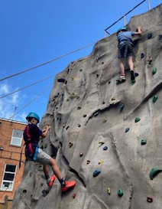
With near perfect weather – dry, sunny, 20 degrees with a cool breeze – we enjoyed a wonderful day of activities. Some groups made fires in the woods as part of Bushcraft, while others completed low ropes, climbing (indoor and outdoor) and axe-throwing. Once again, it is so brilliant to see our children co-operate and show lovely teamwork as they cheered each other on to reach their best height on the climbing wall. The children are also very generous with their praise of each other and have really pulled together to be like a family and support each other. Well done, guys!
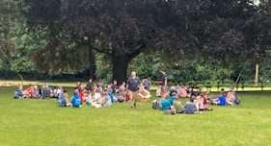
Making the most of the idyllic conditions, we all had lunch outside. A picnic for over 60 children under the shade of huge oak trees was a very special experience. Most importantly, the children got a huge piece of flapjack each (but there was none left for the staff ). Having finished our lunch, the staff at the centre offered to have a game of footie with the children. This resulted in 7 staff plus an old man (Mr Emery) playing against a large group of kids. 2-2 was a fair result, with Mr Emery being “megged” on two occasions.
It has been super to see children having some free time and having fun with their friends while playing simple games like rolling down a grass bank – it seems to be quite a craze!
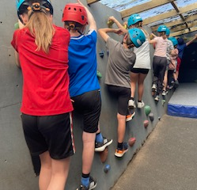
This evening, the menu for tea was very popular with tasty pizza or fish fingers, with potato wedges and sweetcorn and peas, followed by various cake and a selection of fruit. I think I may have seen a child eat some salad, but I am not quite sure .
This evening as we write, the children are completing a Scavenger Hunt in the beautiful grounds, their squeals of laughter echoing all round. We hope for a good night of sleep. I mean, the kids should be tired out by now, shouldn’t they? Here’s hoping…
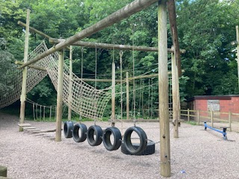
Tomorrow, will see us pack our bags, tidy dorms and complete a full morning of activities (maybe someone will get to push Mrs Vardy or Mr Emery off the high tower? Obviously with a harness and rope ). We aim to leave Standon Bowers on the coach just before 2pm and be back at school for 3pm. Friday afternoon traffic can be unpredictable however, so we will text you if there is any change.

