Thomas Russell Junior School

The place to be YOUR BEST

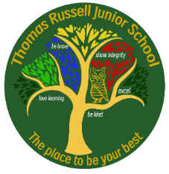
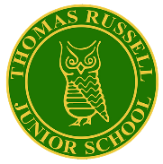
Newsletter

Issue No. 32 Headteacher: Mr J Emery 12 July 2024
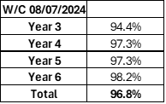


Well done Year 6 for hitting the TRJS target of 98%. A number of parents across the school have taken family holiday during term time which has affected our attendance overall. Such absence has a marked detrimental impact on the progress of pupils; for this reason, I urge all parents to avoid taking leave during term times for family holidays. Following the government guidelines, parents will face a penalty notice if this occurs.
Our overall attendance is still above the national, but it would be great to see TRJS reach the 98% target.
A special congratulations to 30 children across the school who have achieved 100% attendance over this year.

HOT CHOCOLATE WITH MR EMERY
Year 3 | Berivan M, Elizabeth S, Max J, Penny M
Year 4 | Charlotte P, Naryan S, William M, Sophia H
Year 5 | Rocco W, Thomas H, Amelia M, Alfie M
Year 6 | Sophie G, Sahaan K, Rhys G, Jude P
Congratulations to everyone who has received the Merit Awards over the last two weeks and will be having hot chocolate and biscuits with Mr E.

KEEPING SAFE
Over recent weeks, there have been a number of issues involving our Y5 and Y6 children and the use of social media. Many children in Y5 and Y6 are on WhatsApp groups. We repeat the advice regarding the age guidelines for this app: 16 years old. This is because younger children do not have the maturity or resilience to deal with potential problems. We have seen unkind and inappropriate comments from a growing number of TRJS pupils; this is having a detrimental impact on the mental health of many children. If your child is on WhatsApp (or similar groups) I urge parents to check your child’s phone on a daily basis. There are reports of children messaging late at night and early in the morning and this is causing many issues between children at school. It is a distraction to learning and it is taking staff a huge part of each day to talk to children and ensure that they are OK. The most concerning trend is reports of children accessing TikTok and Snapchat in forums without the necessary privacy settings in place. There is much research that highlights how unsuitable adults access platforms frequented by young people in order to target and groom them. Please be vigilant and check your child’s devices. See advice below from the NSPCC about tips to keep children safe on social media:
https://www.nspcc.org.uk/keeping-children-safe/online-safety/social-media/#tips
Football Final

On Wednesday 10th July, TRJS football team played in the final of the Dove Valley 7-a-side Football Cup against William Shrewsbury. The game was hard fought with both teams creating a lot of chances. Thomas Russell scored in the first half with a goal from Sahaan. As the half went on, Charlie made some excellent saves to ensure that TRJS went into half time at 1-0. During the second half, William Shrewsbury equalised. However, TRJS never gave up and Max scored a second goal. TRJS went on to create a lot more chances (hitting the post three times) and with Rocco and Max staying strong at the back, we won the match 2-1. Well done to Thomas Russell, an excellent result and a great way to end an outstanding season! Let’s hope England can replicate the success of TRJS!
Cricket
Last week, the cricket team played in the Dove Valley tournament and maintained 100% record, winning all of the 6 games they played. Miss Sinclair was very impressed with their cricketing skills and teamwork. Highlights included Walter hitting 4 sixes in an over and Oliver bowling a hat-trick (3 wickets in a row)! As the rain came and the tournament could not be completed, another team was judged to win as they scored more runs, even though we won more games. Suffice to say, we were very proud of the team (we all know who were the true winners).
Sports Kit Returns
Please could any child who has been given a TRJS sports kit to attend an after-school tournament please return them by the end of next week. This includes all football kit and any TRJS sports kit used at events such as cricket, rounders and netball. Thank you
Athletics
A reminder that the Dove Valley Athletics is on Tuesday 16 July at 6pm here at TRJS. We have 3 other schools joining us, so if your child is involved and you live in the village, it might be best to leave the car at home as Gilmour Lane will be somewhat busy!

NED Assembly


The children were treated to a lively and entertaining assembly on Thursday afternoon. NED’s mindset mission is to help all children to remember the important message of being positive:
A reminder that NED yo-yos are on sale in school from Friday 12 July through to Tuesday 16 July. Further information was included in last week’s newsletter
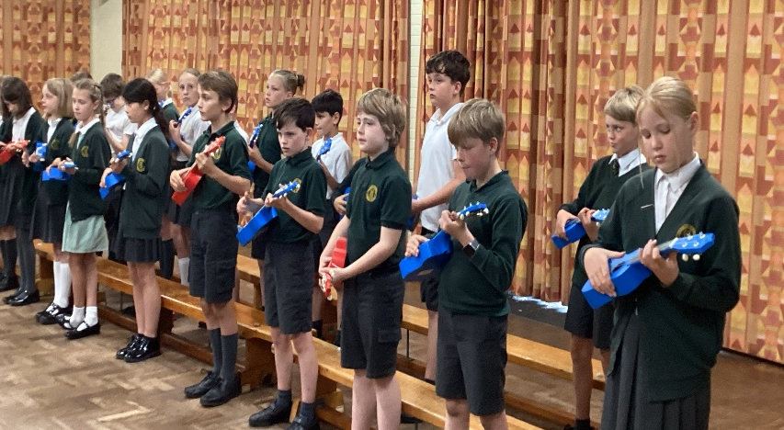
Music At TRJS

It has been a wonderful week for music at TRJS. This week, Year 3 and Year 5 parents have been invited to watch the year group perform a selection of songs that they have learned in their whole class lessons with Hot House Music. Both concerts demonstrated how much the children have enjoyed learning an instrument showing excellent progress. In the audience, was a member of Barton Music Makers, who very kindly donated the money for us to be able to purchase a whole year group set of ukeleles. There were very impressed with the children’s skills on the keyboard (Y3) and ukelele (Y5). Keep going on your musical journey children. I wonder where this might take you next year…?
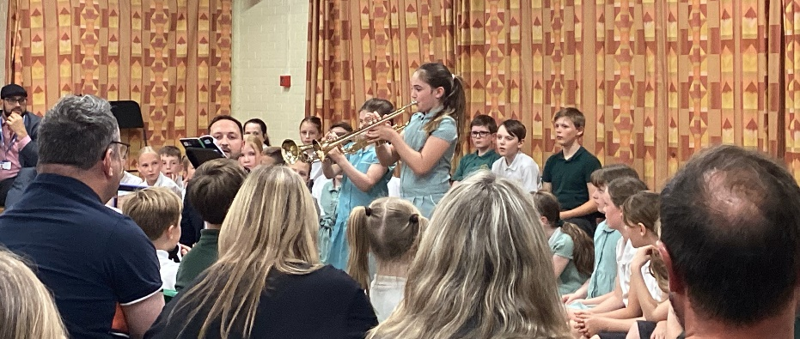
Music Night
On Tuesday 9th July, Thomas Russell’s budding musicians performed to their parents in our first ever music night. During the evening, children who play instruments both in school with Hot House, in addition to those who learn an instrument out of school, showcased their talents on a range of instruments including the piano, saxophone, trumpet and guitar. TRJS choir also shared a range of their favourite songs from the year, singing beautifully as an ensemble as well as showcasing some excellent soloists. The concert finished with a rousing rendition of our school song with the addition of Scarlette, who has learned the song on the ukelele. The HotHouse music staff said they had never been in a school with such kind and talented children, in addition to very supportive parents. What a night! Thank you to our parents/carers for your great support!
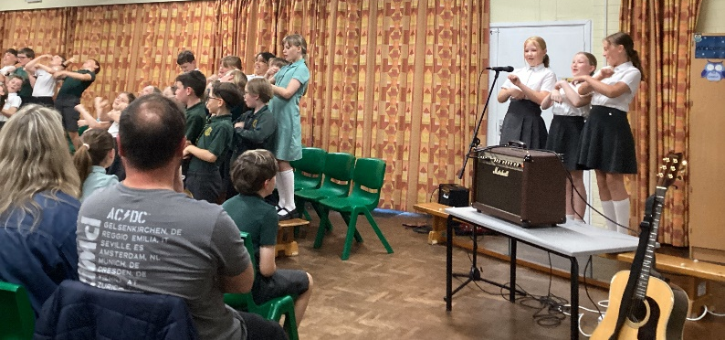
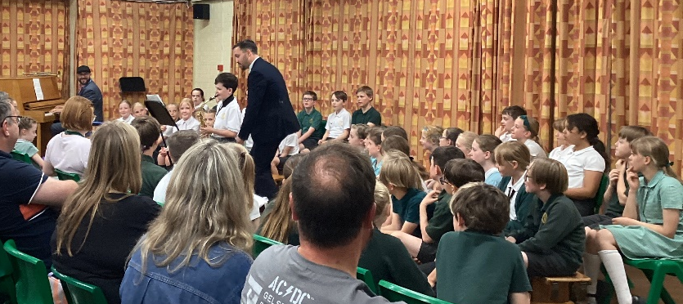

End of Year Reports
A reminder to parents that we will be sending home the end of year reports on Monday 15 July. We ask that all children keep their envelope secure and give it to their parents. Reports should not be opened at school by the children but taken home to read in private. It has been a joy to add my comments to over 250 reports, the vast majority of which are hugely positive and celebrate the wonderful progress and achievement of the children at TRJS. It is such a positive place of learning; it is the place to be your best! If any parent has any questions about the report, then please contact us in the usual way.
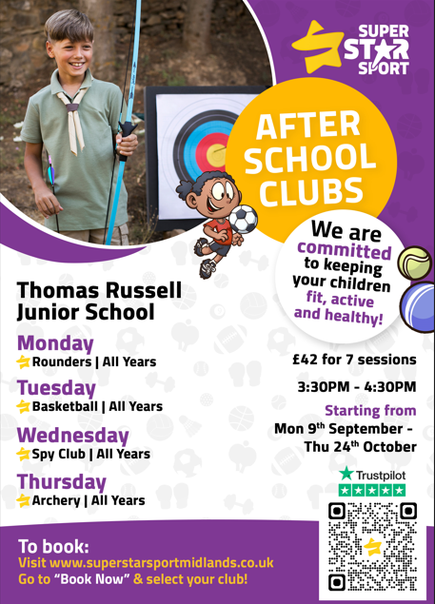
After School Clubs
As usual, there will be a range of clubs offered at school from various members of staff. This information will be sent out to parents in the first week of September.
We also work in partnership with Super Star Sport who offer a range of activities for your children to get involved with. Please see the flier opposite and follow this link to book: https://super-star-sport-midlands.classforkids.io/term/415
Woodland Warriors
Tues 10/09, 17/09, 24/09, 01/10, 08/10, 15/10.
Cost is £36 for 6 weeks and is payable on Parent Pay using this link: www.schoolinterviews.co.uk Code 7gpv5
Bookings open at 6pm Friday 12th July


Year 6 Leavers
A reminder to parents that the Year 6 crew are performing their Leavers’ Assembly to parents on FRIDAY 19 JULY at 10am. At this assembly we will also have a graduation ceremony and The Key Trust will be in attendance to give out some special awards.
Due to health and safety reasons, we can accommodate up to 3 family members per child at this performance. We are not issuing tickets, but this allocation seemed to work very well for the recent Music Night. Please bring your tissues!
The Leavers’ Yearbook and photograph pack will be given out to Y6 children on Thursday 18 July to enable them to get their books signed by their school friends before the end of term.

Early Birds and Night Owls
Please be aware that the booking for next term’s wrap around care is now live and will be open until Friday 26 July. The code for the Autumn Term is as follows:
Early Birds: grf5g Night Owls: 4xyzy

A reminder that there is NO NIGHT OWLS on Friday 19 July.

Clubs Next Week
The only clubs on next week are:
Cricket (Thursday until 4.30) and Soccerstars (Tuesday until 4.30)

Please see the term dates for 2024-2025 below.

There will be one more newsletter for this academic year which will be sent out during the middle of next week.

Wishing everyone a good weekend.

COME ON, ENGLAND. BRING IT HOME!

J Emery

TRJS
Dates for 2024/2025

Monday 2 September INSET DAY
Tuesday 3 September INSET DAY
Wednesday 4 September AUTUMN TERM STARTS for pupils
Friday 25 October INSET DAY
Monday 28 October-Friday 1 November HALF TERM
Friday 20 December AUTUMN TERM ENDS
Monday 23 December-Friday 3 January Christmas Holidays
Monday 6 January SPRING TERM STARTS
Monday 17 February-Friday 21 February HALF TERM
Friday 11 April SPRING TERM ENDS
Monday 14 April – Friday 25 April Easter Holidays
Monday 28 April SUMMER TERM STARTS
Monday 26 May-Friday 30 May HALF TERM
Friday 4 July INSET DAY
Friday 18 July SUMMER TERM ENDS
Monday 21 July INSET DAY

