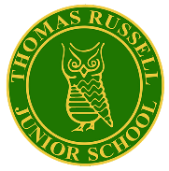
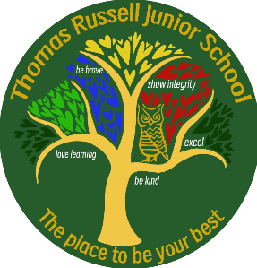
Thomas Russell Junior School
The place to be your BEST
Key Stage 2 SATs Results 2024

Year 6 children take a test in Reading, Maths and SPAG (Spelling, Punctuation and Grammar). The children do not sit a writing test; the scores represent a teacher assessment (TA). The table below shows the percentage of children at TRJS who attained expected (or above) and greater depth in 2024 compared to the national.

Subject | TRJS  Expected + | National Expected + | Difference | TRJS  Greater  Depth | National  Greater  Depth | Difference
Reading | 86% | 74% | +12% | 55% | 29% | +26%
Writing (TA) | 80% | 72% | +8% | 9% | 13% | -4%
SPAG | 86% | 72% | +14% | 54% | 30% | +24%
Maths | 88% | 73% | +15% | 42% | 22% | +20%

Average Scaled Scores
The table below shows the average scaled score in Reading, Maths and SPAGs, compared to the national average scaled score in those subjects:

Subject | TRJS  Average Scaled Score | National  Average Scaled Score | Difference
Reading | 109 | 105 | +4
SPAG | 110 | 105 | +5
Maths | 107 | 104 | +3

Combined Reading, Writing, Maths

 | TRJS | National | Difference
Expected + %  Reading, Writing and Maths Combined | 77% | 61% | +16%
Greater Depth %  Reading, Writing and Maths Combined | 8% | 8% | ---

Mr J Emery
Headteacher

