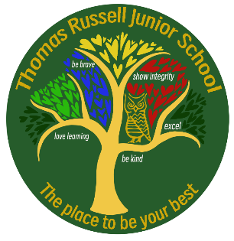
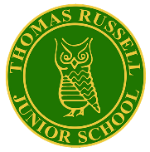
RE: I Can Statements (Year 3)

Explore | I can use a developing vocabulary to describe some key features of religions, recognising similarities and differences.  I can make links between beliefs, practices and sources, including religious stories and sacred texts.  I can begin to identify the impact religion has on believers’ lives.  I can describe some forms of religious expression.
Engage | I can ask important questions about values, commitments, and beliefs, making links between their own and others’ responses, attitudes and behaviour.
Reflect | I can identify and distinguish between the faiths and world views being explored and can express some awareness of my identity within or outside these faiths.  I can understand the importance and reality of existing in a plural context.  I can know that some people do not identify as being religious.

RE: I Can Statements (Year 4)

Explore | I can use a developing vocabulary to describe and show understanding of religious sources, practices, beliefs, ideas, and experiences.  I can make links between them and describe some similarities and differences both within and between religions.  I can describe the impact of religion on people’s lives.
Engage | I can raise, and suggest answers to, fundamental questions of identity, belonging, meaning, purpose, truth, values, and commitments, recognising the implications and consequences of making moral choices.
Reflect | I can apply my ideas about identity and commitment in a diverse world to my own and other people’s lives.  I can describe what inspires and influences myself and others, especially my commitments, values, and choices.  I can recognise in myself and others some reactions to living alongside others who have a different faith or stance.  I can explain why some people do not identify as being religious.
RE: I Can Statements (Year 5)

Explore | I can use an increasingly wide vocabulary to explain the impact of religious beliefs and a non-religious life stance on individuals and communities.  I can show a developing insight into why people belong to religions.  I can demonstrate that similarities and differences illustrate distinctive beliefs within and between religions.  I can suggest possible reasons for this and explain how religious sources are used to provide answers to ethical issues.
Engage | I can ask, and suggest answers to, fundamental questions of identity, belonging, meaning, purpose and truth, values and commitments, relating them to my own and others’ lives and making clear connections between personal viewpoints and action.
Reflect | I can explain what inspires and influences me, expressing my own and others’ views on the opportunities and challenges of commitment in a diverse world.  I can identify the consequences for myself and for others of holding particular beliefs and values.
RE: I Can Statements (Year 6)

Explore | I can use an increasingly rich vocabulary to give informed accounts of religions and beliefs.  I can interpret sources and arguments, explaining the reasons that are used in different ways by different traditions to provide answers for ethical issues.  I can interpret the significance of different forms of religious, spiritual and moral expression.  I can interpret sources and arguments regarding world views/issues.
Engage | I can use reasoning and examples to explore the relationship between beliefs, teachings and world issues.  I can express insights into my own and others’ views on fundamental questions of identify and belonging, meaning purpose and perceived truth.
Reflect | Focussing on values and commitments, I can consider my own response to the opportunities and challenges of living in a diverse world whilst considering the views and experiences of others.  I can talk about examples of religious cooperation and why this is sometimes difficult.

