Y6 Homework – w.c. 08.09.25
Reading: Complete your 20 minutes a day, five times per week reading (at least 3 of those to be your reading scheme book) and record it in your reading diary. Make sure you ask an adult to sign each entry and remember to practise reading aloud (this could be an adult/pet/toy) as well as reading independently (silently). Hand it in next Wednesday (17th September).


Spellings: Log-on to Spelling Shed to practise this week’s words, which focus on the long vowel sound /igh/ spelled with a ‘y’. Usernames and passwords have been stuck in reading records. Please note: some children may have individualised (different) spellings they are working on instead. Your spelling pattern and words to practice for the week will show when you sign-in to Spelling Shed - /j/ sound spelled ‘ge’.

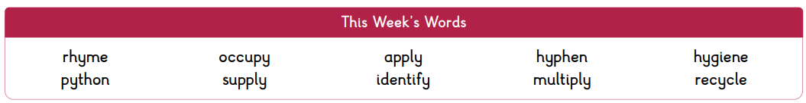

Maths: Times tables play a vital part in numeracy and mental arithmetic. Please complete 30 minutes of Times Tables Rockstars per week. Children know which times tables they will be tested on next week.

Cauliflower Cards: The template for the Christmas cards will be sent home this week. It is entirely up to you how you choose to design your card. Please be mindful of the instructions on the sheet regarding additional embellishments and the size of the design. Orders need to be placed online by FRIDAY 26th SEPTEMBER. Design sheets need to be returned to school by Monday 29th September in order for them to be sent off to the company for printing.


Y6 Parent Meeting: The Y6 team have organised a welcome meeting for all Y6 parents on Monday 22nd September at 6pm. This will be an opportunity to meet the staff and find out about the expectations of Y6 including SATs, residential and preparation for high school.
The meeting is for parents/carers only as any relevant information will be shared with the children throughout the year.
Next Week’s Learning:
- English – we will be proofreading, editing and publishing poems we have drafted in class this week.
- Maths – we will be adding and subtracting using place value, place value to 3 decimal places, multiplying and dividing by 10, 100 and 100 and ordering decimals by up to 3 decimal places.

Contact: Please find below the email addresses for Y6 teaching staff should you need to contact us. We will endeavour to reply to emails within two working days, if it is urgent please contact the office.
lvardy@thomasrussell-junior.staffs.sch.uk
cmurfin@thomasrussell-junior.staffs.sch.uk

