Y6 Homework – w.c. 15.09.25
Reading: Complete your 20 minutes a day, five times per week reading (at least 3 of those to be your reading scheme book) and record it in your reading diary. Make sure you ask an adult to sign each entry and remember to practise reading aloud (this could be an adult/pet/toy) as well as reading independently (silently). Hand it in next Wednesday (24th September).
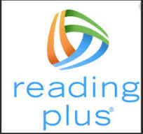
Reading Plus: Complete x3 sessions (at least x2 will be completed at school). These can count as part of your 5 reads above. Record them in your reading record. We are aiming to achieve a reading speed of 185 words per minute and an 80% comprehension average.
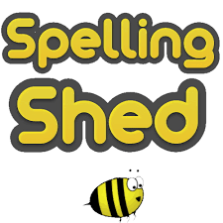
Spellings: Log-on to Spelling Shed to practise this week’s ten challenge words, from the Y5/6 statutory list. Usernames and passwords have been stuck in reading records.
Please note: some children may have individualised (different) spellings they are working on instead. Your spelling pattern and words to practice for the week will show when you sign-in to Spelling Shed - /j/ sound spelled ‘g’.

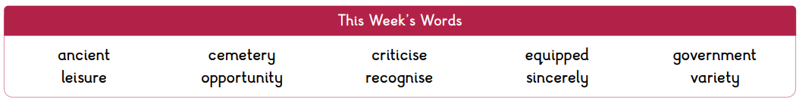

Maths: Times tables play a vital part in numeracy and mental arithmetic. Please complete 30 minutes of Times Tables Rockstars per week. Children know which times tables they will be tested on next week.
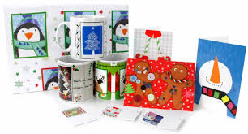
Cauliflower Cards: The template for the Christmas cards will be sent home this week. It is entirely up to you how you choose to design your card. Please be mindful of the instructions on the sheet regarding additional embellishments and the size of the design. Orders need to be placed online by FRIDAY 26th SEPTEMBER. Design sheets need to be returned to school by Monday 29th September in order for them to be sent off to the company for printing.

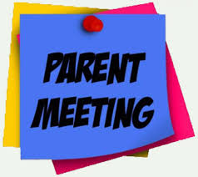
Y6 Parent Meeting: The Y6 team have organised a welcome meeting for all Y6 parents on Monday 22nd September at 6pm. This will be an opportunity to meet the staff and find out about the expectations of Y6 including SATs, residential and preparation for high school.
The meeting is for parents/carers only as any relevant information will be shared with the children throughout the year.

Class Story
6V – We are currently reading ‘The Nowhere Emporium’ by Ross McKenzie. If you wish to bring in your own copy to read along then please do so, but ensure that it is named.
6M – We are currently reading ‘Wild Boy’ by Rob Lloyd Jones. If you wish to bring in your own copy to read along then please do so, but ensure that it is named.
History: This half term we are learning about the Vikings. There is a list of books including fiction and non-fiction uploaded to the website that you may wish to explore to further your knowledge of this period of time.
Next Week’s Learning:
- English – we will be continuing to read and discuss our new text, ‘The Promise’, identifying character traits and demonstrating understanding by writing in role.
- Maths – we will be continuing with multiplying and dividing by 10, 100 and 1,000 - including decimals, rounding - including decimals and revisiting negative numbers.

Contact: Please find below the email addresses for Y6 teaching staff should you need to contact us. We will endeavour to reply to emails within two working days, if it is urgent please contact the office.
lvardy@thomasrussell-junior.staffs.sch.uk
cmurfin@thomasrussell-junior.staffs.sch.uk

