Y6 Homework – w.c. 22.09.25

Reading: Complete your 20 minutes a day, five times per week reading (2-3 of those to be your reading scheme book) and record it in your reading diary. Make sure you ask an adult to sign each entry and remember to practise reading aloud as well as reading independently (silently). Hand in your reading record next Tuesday 30th September. Please note the change of date.
Reading Plus: Complete x3 sessions (at least x2 will be completed at school). These can count as part of your 5 reads above. Record them in your reading record. We are aiming to achieve a reading speed of 185 words per minute and an 80% comprehension average.

Spellings: Log-on to Spelling Shed to practise this week’s new list of words, which all have a /shul/ sound spelled -cial (after a vowel). Due to next week’s residential, these will not be tested until Friday 10th October. Usernames and passwords are in reading records. Please note: some children may have individualised (different) spellings they are working on instead. Your spelling pattern and words to practice for the week will show when you sign-in to Spelling Shed - /c/ making an ‘s’ sound.

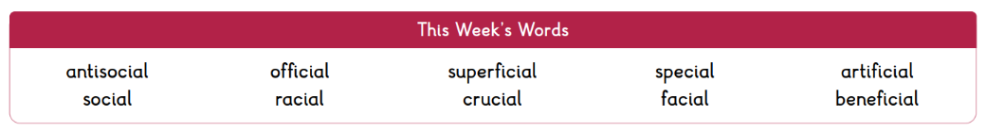


Maths: Times tables play a vital part in numeracy and mental arithmetic. Please complete 30 minutes of Times Tables Rockstars per week. Children know which times tables they will be tested on next week.

Arithmetic: On a Friday, we complete a maths arithmetic challenge. Once the challenge booklets are completed, we will be sending them home. Children are welcome to revisit any of the areas they found tricky. Please note, each group will bring home booklets at different times.
Y6 Meeting: Thank you to everyone who attended the meeting. We hope that you found the information useful. All of the information is uploaded to the website should you need it.

Residential: A reminder that our residential is next week! Please see the kit list provided at the Y6 meeting. Pocket should be a maximum of £5, ideally in coins. All pocket money must be in a labelled envelope/wallet and handed in on Wednesday morning. No electronic devices will be allowed on site at Whitemoor Lakes. Children are welcome to bring a book to read at bedtime should they wish.
Next Week’s Learning:
- English – we will finish reading The Promise and reflect upon its key messages and themes.
- Maths – we will be looking at placing and ordering negative numbers and column addition.

Contact: Please find below the email addresses for Y6 teaching staff should you need to contact us. We will endeavour to reply to emails within two working days, if it is urgent please contact the office.
lvardy@thomasrussell-junior.staffs.sch.uk
cmurfin@thomasrussell-junior.staffs.sch.uk

