Y6 Homework – w.c. 29.09.25
Reading: Read for 20 minutes a day, five times per week (at least 2 of those to be your reading scheme book) and record it in your reading diary. An adult should sign each entry. Practise reading aloud as well as reading independently (silently). Reading Records will be collected in on Wednesday 8th October.


Reading Plus: Complete x3 sessions (at least x2 will be completed at school). These can count as part of your 5 reads above. Record them in your reading record. We are aiming to achieve a reading speed of 185 words per minute and an 80% comprehension average.

Spellings: Log-on to Spelling Shed to continue practising the /shul/ sound spelled -cial (after a vowel) list of words. Due to residential this week, these will be tested on Friday 10th October. Usernames and passwords are in reading records. Please note: some children may have individualised (different) spellings they are working on instead. Your spelling pattern and words to practise all have a ‘c’ making an ‘s’ sound.
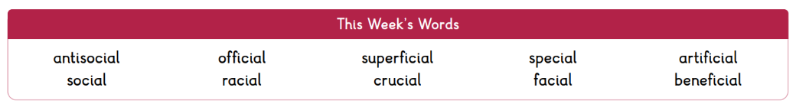



Maths: Times tables play a vital part in numeracy and mental arithmetic. Please complete 30 minutes of Times Tables Rockstars per week. Children know which times tables they will be tested on next week.

Residential: We hope that everyone enjoyed the residential visit and that there is time to rest and recover this weekend!


Next Week’s Learning:
Next week, we will be completing our first set of assessment papers. Please do not panic or worry about these! They merely provide a chance for us to practise assessment style questions and to identify areas of strength/improvement, so we can target our teaching next half term. A positive mindset is key and although the papers may seem tricky at first, it will provide us with a good opportunity to put our new resilience strategies into action! You can do it!


Contact: Please find below the email addresses for Y6 teaching staff should you need to contact us. We will endeavour to reply to emails within two working days, if it is urgent please contact the office.
lvardy@thomasrussell-junior.staffs.sch.uk
cmurfin@thomasrussell-junior.staffs.sch.uk

