Y6 Homework – w.c. 6.10.25
Reading: Read for 20 minutes a day, five times per week (at least 2 of those to be your reading scheme book) and record it in your reading diary. An adult should sign each entry. Practise reading aloud as well as reading independently (silently). Reading Records will be collected in on Wednesday 15th October.

Reading Plus: Complete x3 sessions (at least x2 will be completed at school). These can count as part of your 5 reads above. Record them in your reading record. We are aiming to achieve a reading speed of 185 words per minute and an 80% comprehension average.

Spellings: Log-on to Spelling Shed to practise our new words, based on the /shul/ sound spelled -tial (after a consonant). These will be tested on Friday 17th October. Usernames and passwords are in reading records.
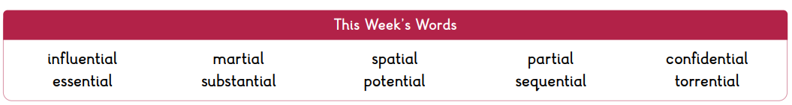
Please note: some children may have individualised (different) spellings they are working on instead. Your spelling pattern and words to practise all have ‘kn’ or ‘gn’ at the start of a word, making a /n/ sound.


Maths: Times tables play a vital part in numeracy and mental arithmetic. Please complete 30 minutes of Times Tables Rockstars per week. Children know which times tables they will be tested on next week.

Assessment Week: A big ‘well done’ to everyone for having a positive attitude towards this week’s first set of Y6 assessment papers. Although we haven’t yet covered all the learning needed to answer some of the questions, you all tried your absolute best and demonstrated resilience to new challenges. Test papers will now be sent home for parents/carers to look at and will form part of our discussions at our forthcoming parent consultation evenings in December.

Next Week’s Learning:
- English – we will be beginning our new unit of learning; using expanded noun phrases and different sentence types to describe, exploring types of nouns and making reasoned predictions/inferences.
- Maths – we will be recapping on formal written methods of addition, subtraction and multiplication.


Contact: Please find below the email addresses for Y6 teaching staff should you need to contact us. We will endeavour to reply to emails within two working days, if it is urgent please contact the office.
lvardy@thomasrussell-junior.staffs.sch.uk
cmurfin@thomasrussell-junior.staffs.sch.uk

