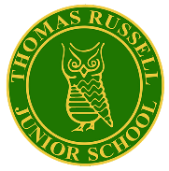
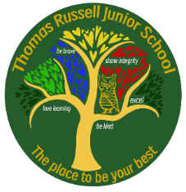
Thomas Russell Junior School
Key Areas for Improvement 2025-2026

Area 1: Safeguarding
- To adopt “My Concern” in all year groups to enhance the recording, monitoring and analysing of safeguarding concerns
Area 2: Inclusion
- To embed the provision and support for Early Reading and Maths, through the effective implementation of EPATT in Reading and Maths
- To ensure the inclusion of all vulnerable pupils in school activities, both in lessons and beyond the classroom
Area 3: Curriculum and Teaching
- To embed effective practice in the science of metacognition with a specific focus on oracy (teacher talk, pupil talk, talk for learning and talk about learning)
- To work more collaboratively with other schools to develop professionally, build on effective practice and moderate and validate the curriculum and assessment
- c) To enhance teaching and learning across the curriculum by the effective use of technology especially iPads
Area 4: Achievement
- To implement a revised approach to guided reading while raising the engagement of all pupils in using Reading Plus to maintain high standards at expected (90%+) and greater depth (50%+) in Y3-5 and by the end of KS2
- To embed the whole writing process and ensure that teachers provide children with the skills needed to edit and publish accurate work to raise standards at expected (85%) and greater depth (15%) in Y3-5 and by the end of KS2
- To embed the approach to reasoning in maths and raise standards at expected (88%) and greater depth (40%) in Y3-5 and by the end of KS2
Area 5: Attendance and Behaviour
- To refine the positive behaviour policy with a focus on RESILIENCE to help all children regulate and resolve any problems/conflicts
- To raise whole school attendance to 97.5% and reduce the number of PAs (persistent absentees) to less than 3%, with a specific focus on vulnerable children
Area 6: Personal Development and Wellbeing
- To enhance the support for the well-being of children through a focus on RESILIENCE and a targeted approach to encourage inclusion for all pupils in all areas of the curriculum
- To implement the OPAL playground project and promote mental health through play; achieve OPAL accreditation by Summer 2026
- To prepare for the implementation of the new RHE curriculum for September 2026
Area 7: Leadership and Governance
- To embed coaching for teachers to embed science of metacognition and oracy
- To enhance the partnership with parents by further communication and community events
- To enhance the effective role of governors by working more collaboratively with JTMAT to ensure effective and efficient systems and processes; complete due diligence to join the JTMAT
- To enhance the systems and processes for safeguarding, behaviour, communication and security to ensure we have efficient processes and enhanced data analysis

