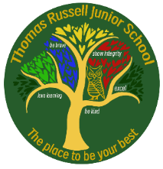

Week 1: Friday 7th November 2025

Have you completed your homework?

Weekly checklist
Reading:
Read at least 5 times a week. Written in the Reading Record (we check these on Mondays)

Reading Plus
Complete your x5 sessions (including at least x2 completed at school)
**These can count as part of your 5 reads above. Record them in your reading record.

Spellings: Please refer to Medium Term Plan - Stage 4 page 4
This can be found on TRJS website: our learning: year 4 – 4th tab down titled spelling yearly overview – page 4
These are your spellings to practice:
Step 9:
Words ending ’-ly’
sadly, completely, wildly, bravely, gently, foolishly, proudly, horribly, nervously, happily

Times Tables
Practise for at least 30 minutes over the week on TT Rock Stars.


OPAL Reminder:
We actively encourage the children to use the school field all year round as part of our OPAL play. We ask that all children bring in a pair of wellies so that they can continue to use the field despite the wet weather. Children are also permitted to bring in waterproof over trousers / snow suits should they wish.

MATHS: Fractions
WORDS OF THE WEEK: numerator, denominator, greater than, smaller than, equal to,

ENGLISH: Syllabic Poetry
WORDS OF THE WEEK: nouns, verbs, adjectives, adverbs, Haiku, syllables, poem
determiner, syllable, synonyms, noun phrase

Children have come home with a competition entry sheet, which looks like this.

SCHOLASTIC BOOKMARK COMPETITION


