Y6 Homework – w.c. 03.11.25
Reading: Read for 20 minutes a day, five times per week (at least 2 of those to be your reading scheme book) and record it in your reading diary. An adult should sign each entry. Practise reading aloud as well as reading independently (silently). Reading Records will be collected in on Wednesday 12th November. Please can all parents/carers support pupils to write in reading records as when checking these on a weekly basis, we are becoming slightly concerned by the lack of out of school reading being completed at present. Hopefully it IS being done, but maybe not recorded! Thank you

Reading Plus: Make sure all of your x5 reading assignments and your x1 vocabulary assignment have been completed for this week. At school, we have timetabled daily Reading Plus sessions so this should leave a minimal amount to complete at home. Remember: these can count as part of your 5 reads above. Record them in your reading record. We are aiming to achieve a reading speed of 185 words per minute and an 80% comprehension average.
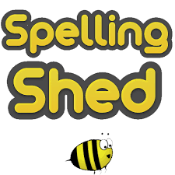
Spellings: Log-on to Spelling Shed to practise our new words, based on words with an /oa/ sound spelled ‘ou’ or ‘ow’. These will be tested on Friday 14th November. Usernames and passwords are in reading records.

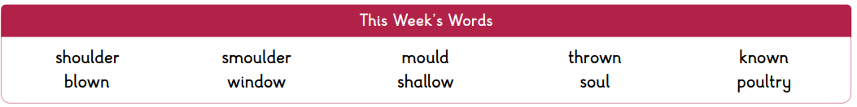
Please note: some children may have individualised (different) spellings they are working on instead. Your spelling pattern and words to practise all end in -le.


Maths: Times tables play a vital part in numeracy and mental arithmetic. Please complete 30 minutes of Times Tables Rockstars per week. Children know which times tables they will be tested on each week.


CGP: We will be setting tasks from the CGP books on a fortnightly rotation. Week A will be MATHS and week B will be SPAG. Children will need to have the relevant CGP book in school on a FRIDAY to be marked. Having different deadlines for homework tasks is in preparation for high school where the children will be expected to manage their time in order to meet deadlines. The alternate book to the homework task will be kept in school. This has all been explained to the children in school .

Maths CGP: Y6 Pages 6 and 7 (Place Value in very Large Numbers and Rounding Whole Numbers). This will be marked on Friday 14th November.


OPAL: As part of our OPAL play, we actively encourage the children to use the school field all year round. We ask that all children bring in a pair of wellies so that they can continue to use the field despite the wet weather. Children are also permitted to bring in waterproof over trousers / snow suits should they wish.
Stay and Play: A reminder that you are warmly invited to join us to experience OPAL play with your children on Tuesday 11th November. Please see the email from school with further details.

Scholastic Book Fair Competition: As you will read in this week’s newsletter, we will be holding a Scholastic Book Fair at school on Monday 17th November (for Y3 & Y5) and Wednesday 19th November (for Y4 & Y6). Children have been sent home with a competition entry form to ‘Design A Bookmark’, based on your favourite book character. There are five prizes of a £5 voucher to spend – so get your creative caps on! There is a spare copy of the sheet attached below.
Next Week’s Learning:
- English – we continue to read more of our ‘Boy in the Tower’ class text, focussing on the character of Mum and her emotions.
- Maths – we will be recapping on equivalent fractions, simplifying fractions and comparing fractions.

Contact: Please find below the email addresses for Y6 teaching staff should you need to contact us. We will endeavour to reply to emails within two working days, if it is urgent please contact the office.
lvardy@thomasrussell-junior.staffs.sch.uk
cmurfin@thomasrussell-junior.staffs.sch.uk



