Y6 Homework – w.c. 10.11.25
Reading: Read for 20 minutes a day, five times per week (at least 2 of those to be your reading scheme book) and record it in your reading diary. An adult should sign each entry. Practise reading aloud as well as reading independently (silently). Reading Records will be collected in on Wednesday 19th November.

Reading Plus: Make sure all of your x5 reading and your x1 vocabulary assignment have been completed for this week. Remember: these can count as part of your 5 reads above. Record them in your reading record. We are aiming to achieve a reading speed of 185 words per minute and an 80% comprehension average.
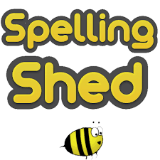
Spellings: Log-on to Spelling Shed to practise our new words, based on words with an /oa/ sound spelled ‘ou’ or ‘ow’. These will be tested on Friday 21st November.
Usernames and passwords are in reading records.

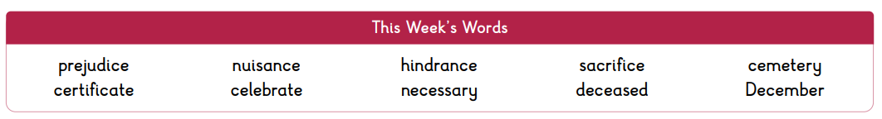
Please note: some children may have individualised (different) spellings they are working on instead. Your spelling pattern and words to practise all end in -el.


Maths: Times tables play a vital part in numeracy and mental arithmetic. Please complete 30 minutes of Times Tables Rockstars per week. Children know which times tables they will be tested on each week.


CGP: We will be setting tasks from the CGP books on a fortnightly rotation. Week A will be MATHS and week B will be SPAG. Children will need to have the relevant CGP book in school on a FRIDAY to be marked. Having different deadlines for homework tasks is in preparation for high school where the children will be expected to manage their time in order to meet deadlines. The alternate book to the homework task will be kept in school. This has all been explained to the children in school .

Grammar CGP: pages 8 and 9 on Synonyms and Antonyms. This will be marked on Friday 21st November.

Scholastic Book Fair
Y6 children and their parents/carers are invited to visit our Scholastic Book Fair in the Hall on Wednesday 19th November between 3.30-4.30pm. CASH only please.

Alternatively, if you are unable to accompany your child after school, there will be an opportunity to purchase books at break time on Thursday 20th November. Please bring any coins/notes in a named, sealed envelope.


OPAL: As part of our OPAL play, we actively encourage the children to use the school field all year round. We ask that all children bring in a pair of wellies so that they can continue to use the field despite the wet weather. Children are also permitted to bring in waterproof over trousers / snow suits should they wish.

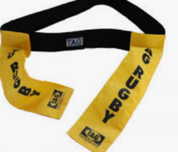
Outdoor PE: Our outdoor PE this half term is tag rugby. Please bring in a spare pair of trainers / football boots to wear for the session as we will be on the field and it can be muddy! You will also need a plastic bag to put your muddy boots in after the session.

Next Week’s Learning:
- English – we will be planning and drafting a newspaper report on the events unfolding in Camberwell (our Boy in the Tower text).
- Maths – we will be recapping on converting between improper fractions and mixed numbers, adding and subtracting fractions with ‘like’ and ‘unlike’ denominators and calculating fractions of amounts.


Contact: Please find below the email addresses for Y6 teaching staff should you need to contact us. We will endeavour to reply to emails within two working days, if it is urgent please contact the office.
lvardy@thomasrussell-junior.staffs.sch.uk
cmurfin@thomasrussell-junior.staffs.sch.uk

