Y6 Homework – w.c. 08.12.25
Reading: Read for 20 minutes a day, five times per week (at least 2 of those to be your reading scheme book) and record it in your reading diary. An adult should sign each entry. Practise reading aloud as well as reading independently (silently). Reading Records will be collected in on Wednesday 17th December.

Reading Plus: Make sure all of your x5 reading and your x1 vocabulary assignment have been completed for this week. Remember: these can count as part of your 5 reads above. Record them in your reading record. We are aiming to achieve a reading speed of 185 words per minute and an 80% comprehension average.

Spellings: Log-on to Spelling Shed to practise our new list of ten spelling words with the suffix -ably. These will not be tested until after the Christmas break on Friday 9th January. Usernames and passwords are in reading records.
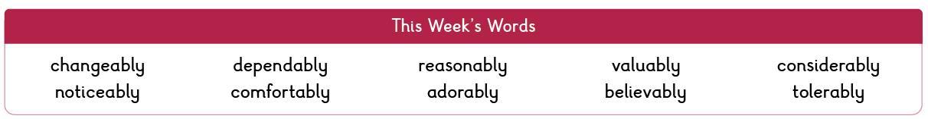

Please note: some children may have individualised (different) spellings they are working on instead. Your spelling pattern is: words where ‘y’ makes an /igh/ sound.


Maths: Times tables play a vital part in numeracy and mental arithmetic. Please complete 30 minutes of Times Tables Rockstars per week. Children know which times tables they will be tested on each week.

SPAG CGP: pg 10 and 11 – Determiners and Pronouns. This will be marked on Thursday 18th December. Make sure your book is in school on this date.



There will be no homework set next week. Have a wonderful holiday! We look forward to seeing you in January.


Contact: Please find below the email addresses for Y6 teaching staff should you need to contact us. We will endeavour to reply to emails within two working days, if it is urgent please contact the office.
lvardy@thomasrussell-junior.staffs.sch.uk
cmurfin@thomasrussell-junior.staffs.sch.uk

