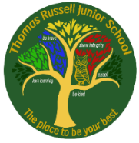

Set: Friday 9th January 2026 Due in: Wednesday 14th January

Weekly checklist | ü
Reading - read for 20 minutes a day, five times per week (at least 2 of those to be your reading scheme book) and record it in your reading diary. An adult should sign each entry. Practise reading aloud as well as reading independently (silently). Reading Records will be collected in on Wednesday 14th January.

Reading Plus - complete your x5 reading assignments (including at least x3 completed at school) **These can count as part of your 5 reads above. Record them in your reading record. We are aiming to achieve a reading speed of 185 words per minute and an 80% comprehension average – check your dashboard to see your data!
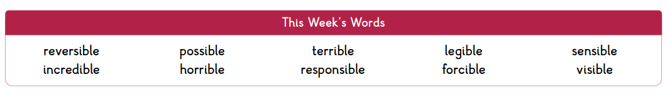
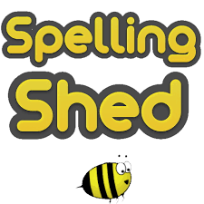
Spellings - log-on to Spelling Shed (usernames and passwords in reading records) to practise our new list of ten words, which all end in the suffix +IBLE. These will be tested on Friday 16th January.
Please note: some children may have individualised (different) spellings they are working on instead. Your spelling pattern is: words ending in ‘y’ which change to +IES.

Times Tables
Practise for at least 30 minutes over the week on TT Rock Stars. Children know which times tables they will be tested on but remember to revise ALL tables facts up to 12x12 regularly to maintain their speedy recall.
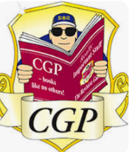
CGP Books: We will be setting tasks from the CGP books on a fortnightly rotation. Week A will be MATHS and week B will be SPAG. Children will need to have the relevant CGP book in school on a FRIDAY to be marked.

Maths CGP: pg 10 an 11 on multiplication and division. This will be marked on Friday 16th January. Make sure your book is in school on this date.

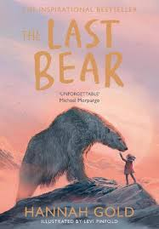
Next week:
English – we will be beginning to read ‘The Last Bear’ by Hannah Gold. If you have a copy at home, please feel free to bring it into school (write your full name inside).

Maths – we will be learning about angles.

Science – our new unit of learning is ‘Light’. As we will be conducting lots of practical activities and investigations, we would be grateful if you have a small torch at home, please bring it in to use in our lessons.


A big thank you from all the Y6 Team for the lovely cards and presents we received for Christmas. We are very grateful and feel very appreciated Happy New Year to you all!

