

Thomas Russell Junior School

Positive Behaviour Policy

Date approved by Governing Body: January 2026
Review date: October 2027

1 Aims and expectations

1.1 It is a primary aim of our school that every member of the school community feels valued and respected, and that each person is treated fairly and well. We are a caring community, whose values are built on mutual trust and respect for all. The school positive behaviour policy is designed to support the way in which all members of the school can live and work together in a supportive way. Everyone has the right to feel happy, safe and secure and we will implement this policy to support in achieving that.

1.2 The school has a number of school rules, but the primary aim of the positive behaviour policy is a means of promoting good relationships, so that people can work together with the common purpose of helping everyone to learn, not a system to enforce rules. We want children to learn to follow rules because morally they represent the correct way to behave rather than for fear of the consequences. Part of this learning includes accepting that an individual may not always understand or agree with rules; however, they are implemented consistently and fairly for the best interests of all. This policy supports the school community in aiming to allow everyone to work together in an effective and considerate way.

1.3 We treat all children fairly and apply this positive behaviour policy in a consistent way.

1.4 This policy aims to help children to grow in a safe and secure environment, and to become positive, responsible and increasingly independent members of the school community and wider world.

1.5 The school rewards good behaviour, as it believes that this will develop an ethos of kindness and co-operation. This policy is designed to promote good positive behaviour, rather than merely deter anti-social behaviour. This policy operates in line with the Anti-bullying Policy and Attendance Policy.

1.6 Our school values thread through all we say and do. We want ALL pupils to be the very best they can be. TRJS is the place to:
- Be kind - we work together, respect each other; everyone is safe and included
- Be brave - we have a positive mindset; we are resilient and have a go;
- Show integrity - we make the right choices to be honest, fair and responsible, even when no one is watching
- Love learning - we are articulate communicators, curious learners who have fun and love to solve problems
- Excel - we aim high, achieve the highest standards, always give our best and are very proud of what we do
  - Resilience is understood as ‘bouncebackability’ and the ability to cope with difficult things. In helping children to develop resilience, we support the following principles: positive relationships, community support, cultural connections, personal skills
We teach skills for building resilience through our school values, assemblies and PSHE lessons. See Appendix 6 for phrases we use in lessons and in conversations with the children to support the development and build resilience.
2 Rewards and consequences

2.1 We praise and reward children for good behaviour in a variety of ways:
- teachers congratulate children and give out house points;
- each week the teacher nominates a child from their class to receive the Weekly Values Award; each child receiving the Weekly Values Award receives a certificate in the Celebration assembly; along with an explanation from their teacher as to why they deserve it based on how they have shown one of our school values;
- A Headteacher’s Award is given to children demonstrating the school values, either in their work or behaviour, these are recorded and once children receive three HTAs they get a certificate and a letter home from the Headteacher and a certificate in assembly.
- See Appendix 1 - Rewards and Consequences Ladder for the full range and order of rewards and consequences.

2.2 The school acknowledges all the efforts and achievements of children, both in and out of school, children are given the opportunity to share these in Celebration Assembly, including items such as music or swimming certificates, karate belts and a range of other achievements etc.

2.3 The school employs a number of consequences, these help to enforce the school rules and to ensure a safe and positive learning environment. We employ each consequence appropriately to each individual situation.
- We expect children to listen carefully in lessons and in assembly. If they do not do so, we ask them either to move to a place nearer the teacher, or to sit on their own.
- We expect children to try their best in all activities. If they do not do so, we may ask them to redo a task either at break or lunchtime.
- If a child is disruptive in class, the staff will give them a reminder of the appropriate behaviour. If a child misbehaves repeatedly, we give the child time to regulate and is in a position to work sensibly again with others.
- Reminders are given at the start of assembly that children need to listen and not talk when others are talking. If a child is disruptive in assembly, staff may ask them to stay for some Reflection Time immediately after the assembly.
- The safety of the children is paramount in all situations. If a child’s behaviour endangers the safety of others, the class teacher stops the activity and prevents the child from taking part for the rest of that session.
- If a child threatens, hurts or bullies another pupil, the class teacher records the incident on the shared Reflection Time Record (which is saved in Teaching Share (T:) drive) and the child will receive an appropriate consequence. If a child repeatedly acts in a way that disrupts or upsets others, the school contacts the child’s parents and seeks an appointment in order to discuss the situation, with a view to improving the behaviour of the child.

2.4 The class teacher discusses the School Values with each class with regard to how these look in the classroom and playground (see appendix 4). This is sent home at the start of every year so that parents/carers can discuss it with their child. In addition, each class also has its own Class Charter, which is created at the start of the year and agreed by the children and displayed on the wall of the classroom. In this way, every child in the school knows the standard of behaviour that we expect in our school. If there are incidents of behaviour that do not meet our expectation, the class teacher may discuss these with the whole class during class assemblies or as a year group, or whole school.
2.5 The school does not tolerate bullying of any kind. If we discover that an act of bullying or intimidation has taken place, we act immediately to stop any further occurrences of such behaviour. While it is very difficult to eradicate bullying, we do everything in our power to ensure that all children attend school free from fear. Please see our Anti-Bullying Policy, as well as the child-friendly posters showing the definition of bullying, roles involved in bullying and flowchart for reporting bullying.

2.6 All members of staff are aware of the Government and Staffordshire advice regarding the use of reasonable force in schools. This can be found at: EPS-RPI-Guidance-2022-electronic-version.pdf (staffordshire.gov.uk)Reducing the need for restraint and restrictive intervention (publishing.service.gov.uk)
https://www.gov.uk/government/uploads/system/uploads/attachment_data/file/444051/Use_of_reasonable_force_advice_Reviewed_July_2015.pdf The school has a Restrictive Physical Intervention Policy which follows this guidance and any actions taken by school staff will be in line with this advice.

2.7 Our children get many opportunities for privileges and responsibilities including: being a subject ambassador, having a classroom monitor role, being House Captain, Y6 duties or representing school at events outside of school. We expect children to show our school values in these roles. If a child is on a Behaviour Chart (see Appendix 1 - Rewards and Consequences Ladder) they will be expected to show measurable improvements against their targets after an agreed length of time, in order to keep school privileges and responsibilities. If this is not the case, staff may consider temporary or permanent removal of certain privileges and responsibilities. Once a child is on a School Report (see Appendix 1 - Rewards and Consequences Ladder), privileges and responsibilities will be withdrawn until the child achieves their targets and finishes the report process. Privileges and responsibilities may be withdrawn for a single serious incident.

2.8 The school has a duty to ensure the safety of all pupils. If a child’s behaviour compromises their own safety or that of others, including one incident of serious nature or poor behaviour over time, a risk assessment will be considered. This will apply to inclusion in trips out of school, residential stays, learning outside the classroom and before/after school activities. This may include control measures that

2.9 There are certain school rules which embody our School Values which are considered to be non-negotiable. In these cases, the usual warnings are not needed. The following rules, if not followed, may result in a direct reflection time:
- Showing respect to staff and not answering back
- Walking quietly around school during lesson time
- Showing respect in assembly and listening to staff and other children when presenting
- Lining up quietly as a class at the end of break times
- Speaking with respect to everyone and avoiding rude, abusive or inappropriate language
- Showing kindness and avoiding hurting others with hands or feet

3 The role of the class teacher / support staff

3.1 It is the responsibility of the staff to ensure that the school rules are enforced for their children throughout school, and that their class behaves in a responsible manner throughout the school day. This responsibility extends to out of school hours for visits and residential trips and also to those children who attend after-school clubs for which they are responsible.

3.2 Staff in our school have high expectations of the children in terms of behaviour and they strive to ensure that all children work to the best of their ability. Staff treat all children in their class with respect and understanding. They expect the same in return from children and parents.

3.3 Staff treat each child fairly and enforce this positive behaviour policy consistently. However, we recognise that reasonable adjustments will need to be made for some pupils in some circumstances, such as those with additional needs. We do this to ensure that the rewards and consequences given are ‘a proportionate means of achieving a legitimate aim’. Taken from ‘Independent review of behaviour in schools’ (Bennett 2017).

3.4 If a child misbehaves repeatedly in class, the class teacher / support staff keeps a record of all such incidents. In the first instance, the class teacher deals with incidents him/herself in the normal manner. However, if misbehaviour continues, the class teacher seeks help and advice from colleagues and the headteacher. See Consequences ladder in Appendix 1.

3.5 The class teacher / support staff liaises with external agencies, as necessary, to support and guide the progress of each child. The class teacher / support staff may, for example, discuss the needs of a child with the education welfare worker or LA behaviour support service.

3.6 The class teacher reports to parents about the progress of each child in their class, in line with the whole–school policy. The class teacher may also contact a parent if there are concerns about the behaviour or welfare of a child. Use of a Behaviour Chart and Report Card may be used to help support children to regulate their behaviour towards agreed targets (see Consequences Ladder in Appendix 1).

3.7 Regulation. At the start of every morning the Regulation Station is open for specific children to help them regulate before joining their class for the rest of the day. The Regulation Station is also open every lunchtime for any child feeling that may need some time and space to regulate. Every classroom has the Zones of Regulation displayed and this is used to help children understand what zone they are in, but more importantly what they can do to help move them to a more regulated state. Staff use relevant materials including ‘Anywhere Body Breaks, Tools and Big Body Breaks’ and ‘The Zones of Regulation’ to ensure all children are in the best place to learn and excel: https://digitalhub.jkp.com/id004325593 downloadable_reproducibles_zones_curriculum_v1.pdf
Sensory diets are also used where relevant across the school for specific children. 1709883011Sensory Profiling- Sensory Curriculum (1) (1).pdf

3.8 Restorative Practice. Relevant training is used to ensure teachers understand the principles of restorative practice and are confident in holding restorative conversations. We understand that the underlying premise of restorative practices rests with the belief that people will make positive changes when those in positions of authority do things with them rather than to them. It relies on:
- Active listening – fully concentrating on what is being said rather than passively ‘hearing’ the message of the speaker
- Restorative questions – explore everyone’s thoughts and feelings and take an incident from the past/present towards a future solution. We use the questions set out by ABA (Anti-Bullying Alliance) to structure these conversations (Appendix 4). We avoid asking ‘why’ in restorative enquiry. This is because if we ask ‘why’ it may invite a defensive response and communicate that we have already made a judgement.
- Behaviour as communication – what is a pupil’s behaviour telling us about their thoughts and feelings at any given time?

3.9 Staff aim to use the ‘PLACE’ approach when communicating with children in challenging circumstances, which stands for:
- Playful – Playfulness engages and rewires children at precognitive levels and recognises their limited ability to follow instructions. This also conveys acceptance, regardless of the child’s achievements or misdemeanours. Positive non-verbal communication such as soft eye contact and facial expressions, good touch, and a welcoming body posture communicate positivity, as does maintaining a happy school environment.
- Liking – Show the child that you like them by staying calm even when they aren’t. If a child rejects you don’t reject them, and reconnect after disciplining. Find something valuable about the child and try to like that part of them when their behaviour is challenging. Remember, the behaviour is worse when the child is frightened or stressed.
- Accepting – It is easier for children to stay regulated if you can show you accept them and the reasons for their difficulties, while not necessarily accepting the behaviour. Reminding yourself that often it is “can’t do” instead of “won’t do”, that they are doing their best, and their behaviours are a way of communicating needs and fears can help you develop an accepting attitude. You can use accepting expressions like, “I really like you being a part of this class and still it is not okay to …. Let’s see if we can find a better way for you to show me what you need.”
- Curious – Being “curious not furious” about why children act in certain ways. You can convey curiosity by wondering out loud why the child is behaving in a certain way. Simply saying something like, “I wonder why it is so hard for you to wait your turn/queue up for lunch” etc can help a child to stop, think and being to make sense of their feelings and behaviours. This is usually more effective than asking directly what’s bothering them. A child who has ‘switched off’ their feelings may not know why they are upset. An educated guess such as, “I wonder if you are worried about the school trip on Friday,” can also be an excellent way to open discussion, in which you can listen empathically.
- Empathy – Empathy is the most important quality you can have when working with children. To understand the child’s needs we have to put ourselves in their shoes and convey to them that we ‘get it’. For example, “I know that these spellings are hard for you to remember.’ Empathy allows the child to feel their feelings and encourages the release behind emotional and behavioural problems. Try to empathise with the child before disciplining and throughout the employment of any disciplinary measures.

4 The role of the headteacher

4.1 It is the responsibility of the headteacher, to implement the school behaviour policy consistently throughout the school, and to report to governors, when requested, on the effectiveness of the policy. It is also the responsibility of the headteacher to ensure the health, safety and welfare of all children in the school.

4.2 The headteacher supports the staff by implementing the policy, by setting the standards of behaviour, and by supporting staff in the implementation of the policy.

4.3 The headteacher keeps records of all reported serious incidents of misbehaviour in the children’s individual files and these are also recorded in the SIMs system.

4.4 The headteacher has the responsibility for implementing suspensions to individual children for serious acts of misbehaviour. For repeated or very serious acts of anti-social behaviour, the headteacher may permanently exclude a child. See Appendix 2 – Exclusions

5 The role of parents

5.1 The school works collaboratively with parents, so children receive consistent messages about how to behave at home and at school. It can be very difficult and confusing for children when they receive mixed or inconsistent messages about standards and expectations.

5.2 We explain the school values on the school website, and how these are seen in classrooms and on the playground and we expect parents to read these and support them.

5.3 We expect parents to support their child’s learning, and to co-operate with the school, as set out in the ‘What the values look like at school’ which is sent home yearly. We try to build a supportive dialogue between the home and the school, and we inform parents immediately if we have concerns about their child’s welfare or behaviour and expect the same level of communication regarding changes to home situation or other factors that may influence a child’s behaviour.

5.4 If the school uses reasonable sanctions with a child, parents are expected to support the actions of the school. If parents have any concern about the way that their child has been treated, they should initially contact the class teacher, then the Headteacher. If the concern remains, they should contact the school governors. If these discussions cannot resolve the problem, the school complaints procedure may be followed.

6 The role of governors

6.1 The governing body has strategic responsibility for behaviour policies.

6.2 The governing body monitors the effectiveness of the behaviour policy and analyses data on sanctions, rewards and exclusions.

6.3 The headteacher has the day-to-day authority to implement the school behaviour and discipline policies. However, governors may need to form a pupil discipline committee to review decisions as appropriate.

7 Suspension and Permanent Exclusions

7.1 We do not wish to exclude any child from school, but sometimes this may be necessary. The school has therefore adopted the standard national reasons for exclusion. Further information can be found at https://www.gov.uk/government/publications/school-exclusion

7.2 Only the headteacher (or the acting headteacher) has the power to suspend or exclude a pupil from school. The headteacher may suspend a pupil for one or more fixed periods, for up to 45 days in any one school year. The headteacher may also exclude a pupil permanently. In exceptional cases, usually where further evidence has come to light, a further suspension may be issued to begin immediately after the first suspension ends; or a permanent exclusion may be issued to begin immediately after the end of the suspension. (This is in line with point 10 of Suspensions and Permanent Exclusions Guidance Suspension and permanent exclusion guidance.)

7.3 If the headteacher suspends or excludes a pupil, s/he informs the parents immediately, giving reasons for the exclusion. At the same time, the headteacher makes it clear to the parents that they can, if they wish, ask governors to review the decision; in some cases, parents may be able to appeal against the decision. The school informs the parents how to make any such request or appeal.

7.4 The school will provide work for a child to complete during any suspension. The work is expected to be complete and returned to school for the teacher to mark.

7.5 The headteacher informs the LA and the governing body about all exclusions in accordance with the Guidance.

7.6 The governing body itself cannot either suspend or exclude a pupil or extend the suspension period made by the headteacher.

7.7 The governing body has a pupil discipline sub-committee which is made up of at least three members. This committee considers any exclusion reviews on behalf of the governors. This sub-committee consider the circumstances in which the pupil was excluded, consider any representation by parents and the LA, and consider whether the exclusion should be upheld or whether the pupil should be reinstated.

7.9 Following the outcome of the pupil discipline sub-committee, the parent may make an appeal. If this is the case the appeal will be heard by a governor committee of at least three members.

7.9 The headteacher must comply with the outcomes from the discipline sub-committee or the appeals panel.

7.10 Appendix 2 provides further information regarding reasons for suspension or exclusion.

8. Offensive Weapons in School

8.1 It is a criminal offense to have an offensive weapon (including a bladed article) in school in line with the “Offensive Weapons Act” 1996.

8.2 Offensive weapons can include those made for causing injuries, those adapted for causing injuries or any everyday item that has the intention to be used as a weapon.
https://www.gov.uk/government/publications/the-offensive-weapons-act-2019/statutory-guidance-offensive-weapons-act-2019-accessible-version

8.3 If the school has evidence that a child has an offensive weapon, including any type of bladed item, the weapon/article will be photographed, confiscated (if safe to do so) and police will be informed immediately.

8.4 Although the legal definition of a bladed article is one that is 3 inches (7.62 cm) or more, the school will consider any sharp weapon (even if less than 3 inches) to be a reason for suspension or exclusion on the grounds of keeping all children safe. This will include any everyday item that has been brought to school with the intent to threaten or cause harm to others.

8.5 If a child is found to have in their possession at school (or found to have brought into school), on their person or within their belongings, any offensive weapon as outlined above, the school may implement a suspension of up to 5 days in the first instance. The wording of the letter will include “pending further enquiries” to allow time for a full investigation before the final decision as to whether a permanent exclusion may be appropriate.

8.6 If a child was suspended as above and then returned to school, the school would work with the police and other agencies to agree a safety plan for the re-integration of that child which would be discussed with parents prior to the re-integration of the child at school.

8.6 If a child is found to have in their possession at school (or found to have brought into school), on their person or within their belongings, any offensive weapon as outlined above AND uses threatening language or actions towards other children with reference to the weapon or while they are carrying the weapon, the school would implement a permanent exclusion.

9. Monitoring and review

9.1 The headteacher monitors the effectiveness of this policy. S/he also reports to the governing body on the effectiveness of the policy and, if necessary, makes recommendations for further improvements.

9.2 The school keeps a variety of records of incidents of misbehaviour. The class teacher records minor classroom incidents. The headteacher records those incidents where a child is sent to him/her on account of poor behaviour. We also keep a record of any incidents that occur at break or lunchtimes: lunchtime supervisors give written details of any incident when requested.

9.3 The headteacher keeps a record of any pupil who is suspended or permanently excluded.

9.4 It is the responsibility of the governing body to monitor the rate of suspensions and exclusions, and to ensure that the school policy is administered fairly and consistently. The governing body will have due regard to the duties placed upon it by latest Equalities legislation.

Thomas Russell Junior School

Rewards Ladder

Key Trust Awards

Awarded to two children at the end of Y6 for a consistently high standard of behaviour, achievement and outstanding contribution during their 4 years at TRJS

Values Awards

Awarded to ten children at the end of Y6 for outstanding demonstration of the school values over four years: Kind, Brave, Integrity, Love Learning, Excel

Special certificate 100% Positive Behaviour all year

Super Class Award for a week of exceptional effort from the whole class

Certificate at end of term for 100% Positive Behaviour

Certificate for 3 Headteacher Awards

Weekly Values Award announced in Whole School Assembly with a Hot Chocolate treat with Mr Emery

Headteacher Awards

Class Rewards for School Values

Recognition in Celebration Assembly for House Points

Stickers and House Points

Praise, smiles and positive comments

15 mins ‘Friday Free Time’ given to every child

Thomas Russell Junior School

Consequences Ladder

Permanent Exclusion

Suspension

Lunchtime Suspension

Further 2 weeks on Red Report Card led by HT

Meeting between parent, child and class teacher to discuss behaviour with follow up meeting

2 weeks on Red Report Card led by HT / DHT

With clear expectations of behaviour set by up to 3 agreed targets.

Meeting between parent, child and class teacher to discuss behaviour with follow up meeting

Loss of privileges and responsibilities

2 weeks on Green Behaviour Chart led by the class teacher

With clear expectations of behaviour set by up to 3 agreed targets.

Conversation with the parent, child and class teacher to discuss behaviour with follow up meeting

3 Reflection Time Records

Parents will be contacted to discuss the incidents and behaviour

During Playtime or Lunchtime: time out on a bench (up to 5 min)

If behaviour is persistent:

Reflection in afternoon playtime Restorative Flowchart used to prompt reflection. Recorded on the Reflection Time Record.

AND / OR

Partner class to complete work If continually interrupting other children’s learning. Recorded on the Reflection Time Record as ‘PC’.

During class time: A second verbal warning of the consequences of poor behaviour – teacher makes own notes (no names on the board)

During class time: A verbal warning of the consequences of poor behaviour – teacher makes own notes (no names on the board)

‘The Look!’ or a gentle word

In behaviour does not follow the “non-negotiable” rules (see section 2.9) this may result in a reflection time without any further warnings.

For behaviour that is more severe e.g. persistent defiance, fighting, bullying, swearing, derogatory language, racist, homophobic behaviour, damage to school property – these will result in instant referral to a senior teacher with a further consequence relevant to the behaviour.

For behaviour of a very serious nature, this process can be escalated.

Positive Behaviour Policy – Appendix 2

(Use this list, or Staffordshire Guidance, whichever is most recent)
This list provides descriptors of reasons for exclusions. The 12 categories should cover the main reasons for exclusions and the "other" category should be used sparingly. The further detail suggesting what the descriptors cover should be used as a guide.

Physical assault against pupil
Includes:
- fighting
- violent behaviour
- wounding
- obstruction and jostling

Physical assault against adult
Includes:
- violent behaviour
- wounding
- obstruction and jostling

Verbal abuse / threatening behaviour against pupil
Includes:
- threatened violence
- aggressive behaviour
- swearing
- homophobic abuse and harassment
- verbal intimidation
- carrying an offensive weapon

Verbal abuse / threatening behaviour against adult
Includes:
- threatened violence
- aggressive behaviour
- swearing
- homophobic abuse and harassment
- verbal intimidation
- carrying an offensive weapon

Bullying
Includes:
- verbal
- physical
- homophobic bullying
- racist bullying

Racist abuse
Includes:
- racist taunting and harassment
- derogatory racist statements
- swearing that can be attributed to racist characteristics
- racist bullying
- racist graffiti

Sexual misconduct
Includes:
- sexual abuse
- sexual assault
- sexual harassment
- lewd behaviour
- sexual bullying
- sexual graffiti

Drug and alcohol related
Includes:
- possession of illegal drugs
- inappropriate use of prescribed drugs
- drug dealing
- smoking
- alcohol abuse
- substance abuse

Damage
Includes:
- damage to school or personal property belonging to any member of the school community
- vandalism
- arson
- graffiti

Theft
Includes:
- stealing school property
- stealing personal property (pupil or adult)
- stealing from local shops on a school outing
- selling and dealing in stolen property

Persistent disruptive behaviour
Includes:
- challenging behaviour
- disobedience
- persistent violation of school rules

Other
Includes incidents which are not covered by the categories above but this category should be used sparingly

Positive Behaviour Policy – Appendix 3
Restorative Conversation Flowchart
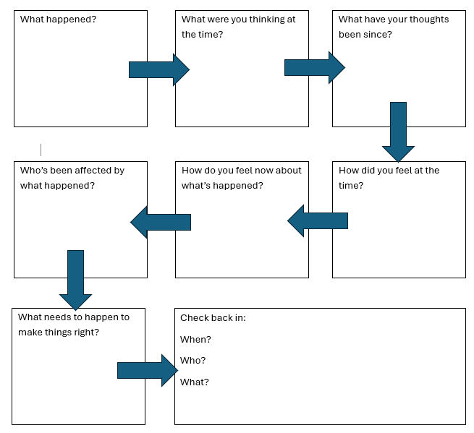

Positive Behaviour Policy – Appendix 4
What do our values look like in the classroom and on the playground?

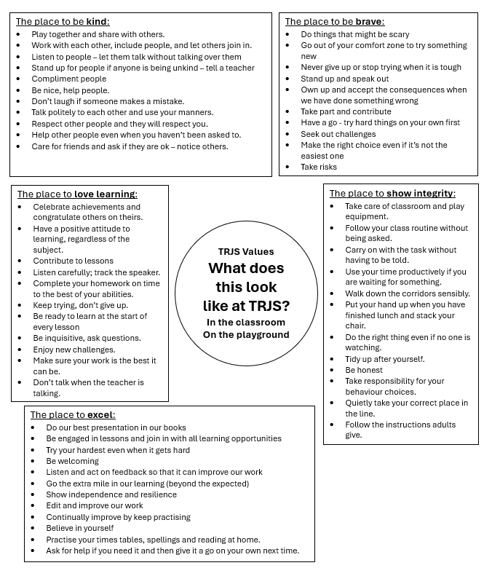

Positive Behaviour Policy – Appendix 5

Class Teacher Procedures

- Every teacher keeps a private book of warnings. Children’s names are not publicly displayed on the board.
- If a child gets three warnings they will lose some of the afternoon playtime that same day for Reflection Time. (If this happens after playtime, it will carry over to the next day). They will reflect on what brought them there by using the questions on the Restorative Conversations Flowchart.
- The class teacher will then record this on the Reflection Time Record (spreadsheet saved in Teaching Share (T:) drive). This will include the reason.
- There is a senior teacher on Reflection Time duty during afternoon play.
- The teacher on duty updates the whole school Reflection Time Record (spreadsheet saved in Teaching Share (T:) drive) to confirm that the Reflection Time has been completed and whether there are any further actions.
- If a child has a more ‘severe’ behaviour incident that requires a more immediate consequence, this is coloured red on the Reflection Time Record.
- ‘What our values look like in school’ is shared with parents and children at the start of the year to read through together.

Positive Behaviour Policy – Appendix 6

Building Resilience:
Words to help conversations with children
when faced with problems or conflict.

1 | “Vase or Faces”  Helps us try to understand that the same thing or situation can be seen in different ways.  Some people see the vase, some people see the faces first.  Let’s try to see things from a different point of view. | 
2 | What’s on your T-Shirt?  What label would you like?  Does your T-shirt say:  Kind, Brave, Fair, Honest, Positive? | 
3 | “Hippo Time is OK”  Everyone needs some time to wallow if you are feeling sad or upset.  We will give you time and space to help you regulate. | 
4 | “Stay in your own lane”  This helps children focus on their path and doing the right thing for them and not being fixated on what others are doing.  “Comparison is the thief of joy.” | 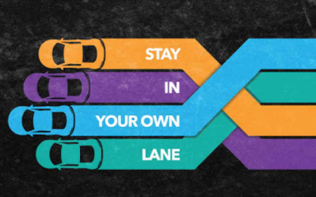
5 | Carpe diem (Latin) “Seize the Day”  Yesterday is history, tomorrow is a mystery. Let's make the best of today: the here and now. | 
6 | “Draw a line under it and move on”  Once you have talked things through and restored things, now it is time to put this behind you and move on. | 
7 | “Let it Go”  Mean words don’t belong to you. | 
8 | “Focus on the things you can control” | 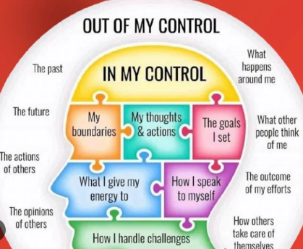
9 | “Nobody but me is gonna change my story.” (Matilda)  It is your story. You can decide how you behave, how you deal with situations. | 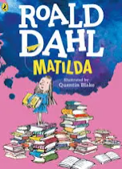
10. | “Let’s not bamboozle the noodle”  Let’s just focus on one thing that we can do to make things better. Let’s not worry about everything.  Take one step at a time. | 
11. | Picture yourself succeeding.  Visualise what it looks like when you have achieved what you want.  How does it feel to be there? | 
12. | Mistakes are part of the plan.  Nobody is perfect.  Today is not perfect, but it is OK.  Sometimes, OK is fine! | 

