Thomas Russell Junior School


The place to be YOUR BEST


Newsletter

Issue No.23 Headteacher: Mr J Emery Friday 24 April 2026
 | w/b 20.04.26
Year 3 | 98.7%
Year 4 | 97%
Year 5 | 98%
Year 6 | 99.5%
TRJS Overall | 98.3%


Wow! Great attendance this week.
Well done, everyone.
5 minutes extra play next week!

HOT CHOCOLATE WITH MR EMERY
Congratulations to everyone who has received the TRJS Weekly Values Award and shared hot chocolate and biscuits with Mr Emery. We had many good jokes today:
Trinity: What did the snowman say to the other snowman? Can you smell carrots?

Year 3 | Ava R, Samuel T
Year 4 | Harry G, Trinity W
Year 5 | Scarlett A-J, Charlotte E
Year 6 | Jack S, William P

OPAL – We Need You!
Our children love OPAL play at lunchtime. We now have a mud kitchen / café, willow arch, willow dome, den building and tyre play to name just a few things.
Our next project is to build a large sandpit for the children to play in. We have a kind offer to dig this out for us, but we will need parental help with the final set up. We are asking any parents available on Saturday 6th June to come to school from 9am-12pm to help us with some OPAL projects.
Our projects include:
- Lining the sandpit - Filling the sandpit with sand
- Painting the storage sheds - Planting up the tyres
- Creating play spaces for the children out of pallets
We kindly ask that you do not bring children to school for this session due to the tools and equipment that will be on site. If you are able to help us out, please email Mrs Vardy (lvardy@thomasrussell-junior.staffs.sch.uk) so that we can send out further information.

Friends of TRJS
A reminder that there is a meeting for any parents interested in being involved in community and fundraising events at 2pm on Monday 27 April.
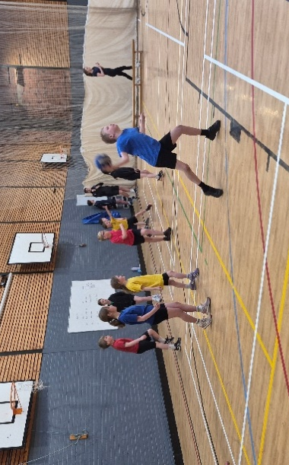
Year 3 and 4 Dodgeball at John Taylor
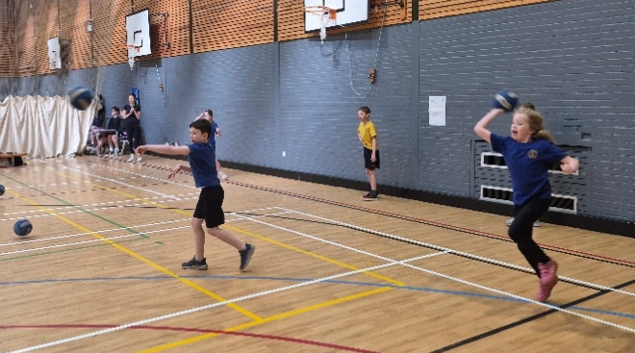
Our Year 3 and 4 pupils took part in an exciting dodgeball tournament on Tuesday at John Taylor High School and represented the school brilliantly throughout the event. The children showed great determination and enthusiasm in every match, finishing in a well-deserved third place.
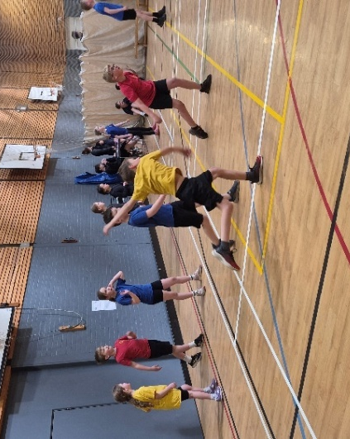
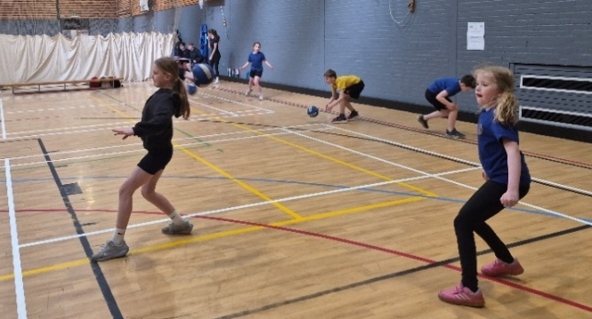
Beyond the final result, the tournament was a fantastic opportunity for the pupils to build confidence, work together as a team and demonstrate excellent sportsmanship. They supported one another, celebrated successes, and showed resilience when faced with challenges — all while having lots of fun along the way.
We are very proud of everyone who took part for their effort, positive attitudes, and teamwork. Well done, Year 3 and 4!

Dove Valley Football

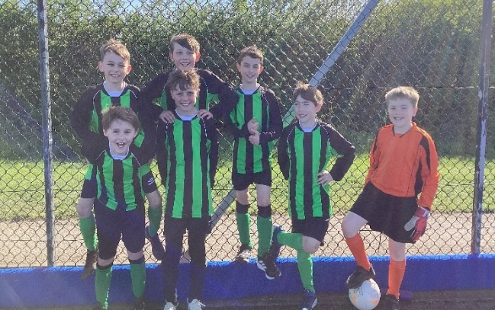
On Tuesday night, TRJS took part in the final league event of the season at Shobnall Leisure Centre. During the tournament, TRJS played games against William Shrewsbury, John of Rolleston, Needwood, Yoxall and Richard Crosse. All of the children played incredibly well, working hard as a team and showing great determination. Over the night, the team’s performances got better and better-winning 2 matches and losing 3 over the course of the evening. Well done to all children who took part!

Summer Term Dates
Please see the list of dates for the summer term at the end of the newsletter. We will add any new dates in RED, as new dates arise.

Fundraising


Epidermolysis Bullosa

Kelly, one of our parents, is running a half marathon to raise funds for a great cause:
“I am raising money for a small charity which supports people with a very rare, painful, life-long skin condition called Epidermolysis bullosa, like my son. Please help me raise as much money as possible as I tackle half a marathon!” Please use this link or QR code to donate. Thank you. https://donate.giveasyoulive.com/fundraising/running-for-all-the-butterflies


Birmingham Children’ Hospital Charity

This year again on Saturday 2nd May, Imogen Mallett (Yr6) will be taking part in the AJ Bell 2.5k Junior Run to raise money for Birmingham Children’s Hospital. This is an amazing feat given she has recently undergone further surgery with them, and although Imogen may not be able to completely run the whole event this year, she will certainly give finishing the race in a better time than last year a good go!! Her Mum will also be running the AJ Bell Half Marathon on the Sunday to raise money for the same cause. They can both be sponsored using the QR code.

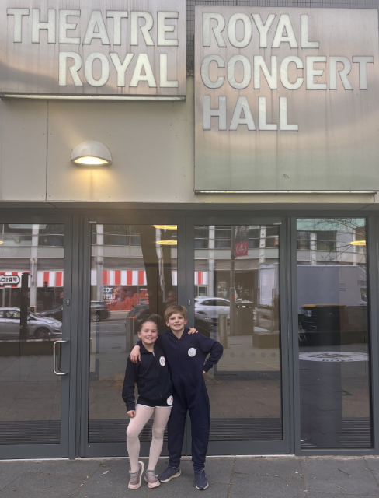
Ballet Stars!
Ryan (Y6) and Scarlett (Y4) both had successful auditions for the English Youth Ballet. They will be performing Swan Lake in July in Nottingham. Wow! What a fantastic achievement!

Beginners Ski & Snowboarding
We still have 3 spaces for Ski Club and 2 spaces for Snowboarding Club. Sessions are for 4 weeks starting next Friday (May 1st). Bookings can be made through the Clubs section of MCAS.


Nature
This week we have been talking about the benefits of being in nature and how this is so good for our mental, emotional and physical wellbeing. Why not get outside and enjoy the sunshine? Have a great weekend.
J Emery

Thomas Russell Junior School

Summer Term 2026

Term Starts: Monday 13 April
Y4 online author visit: Monday 27 April
Friends of TRJS Meeting: Monday 27 April 2pm
May Day Bank Holiday: Monday 4 May
Y6 SATS Week: Monday 11-Thursday 14 May
Y6 Trip to the Staffordshire Regiment Friday 15 May
Meeting for Parents of Y3 (September 2026) Monday 18 May 6pm
Sports Day: Tuesday 19 May
Half Term: Monday 25 May – Friday 29 May
OPAL Volunteer Day: Saturday 6 June
Inset Day (School closed for pupils): Friday 3 July
Term Ends for Pupils: Friday 17 July
Inset Day (School closed for pupils): Monday 20 July

Thomas Russell Junior School

Term Dates 2026-2027

Autumn Term 2026

Inset day (School closed for pupils): Tuesday 1 September
Term Starts for pupils: Wednesday 2 September
Half Term: Monday 26 October – Friday 30 October
Inset Day (School closed for pupils): Monday 2 November
Term Ends: Friday 18 December
Holiday: Monday 21 December – Friday 1 January

Spring Term 2027
Inset Day (School closed for pupils): Monday 4 January
Term Starts for pupils: Tuesday 5 January
Inset Day (School closed for pupils): Friday 12 February
Half Term: Monday 15 February – Friday 19 February
Term Ends: Thursday 25 March
Holiday: Monday 29 March – Friday 9 April
Easter Sunday: Sunday 28 March
Summer Term 2027
Term Starts: Monday 12 April
May Day: Monday 3 May
Half Term: Monday 31 May – Friday 4 June
Inset Day (School closed for pupils): Friday 2 July
Term Ends: Wednesday 21 July
Holiday: Thursday 22 July – Wednesday 1 September
(Thursday 2 September 2027 and Friday 3 September 2027 will be INSET Days, so the Autumn Term 2027 will start for pupils on Monday 6 September 2027.)

