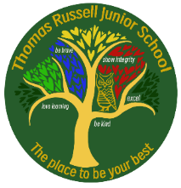
Week 15: Friday 8 May 2026
Have you completed your homework?
Weekly checklist:

Times Tables:
Please see the letter at the bottom of the sheet which informs you about the MTC check and how to support your family.

Reading:
Read five times per week (at least 2 of those to be your reading scheme book) and record it in your reading diary. An adult should sign each entry. Practise reading aloud as well as reading independently (silently). Reading Records will be collected in on Monday.

Reading Plus
Work hard to try and complete your x5 sessions.
We do complete Reading Plus for 15 minutes every afternoon, but please note that this doesn’t mean you don’t have to do any at home. If you haven’t managed your 5 reads in school this needs to be completed at home. If you want to do more - that’s excellent.
We are aiming for 80% or more comprehension success.

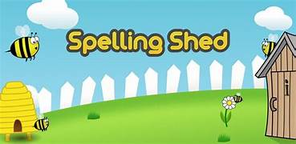
Spellings: Please refer to Medium Term Plan - Stage 4 page 4
This can be found on TRJS website: our learning: year 4 – 4th tab down titled spelling yearly overview – page 4.
Stage 30
Practise your spellings using the sheet and/or using EdShed.

MATHS: subtraction, exchanging, hundreds, tens, ones, efficient methods

ENGLISH: Stories about issues. Features of non-chronological reports. Paragraphs, Amazon Rainforest.

PLEASE BRING IN HEADPHONES FOR FRIDAY’S SPELLING LESSONS.

DESIGN AND TECHNOLOGY
DT : START TO HAVE A LOOK FOR KITE RESOURCES.

Just to let you know that Year 4 will be making their own kites on Monday 18th and Wednesday 20th May.

Children will need to make sure they have their resources (in a named bag) which might include a bin bag, plastic bag, tarpaulin, masking tape, ribbon, string, empty kitchen roll tube etc. We will provide the dowl rods and paints/ colouring pens.

The kite sail has been designed to be no bigger than an A3 piece of paper.
Children have brought home their design, which can be altered if necessary.

ENGLISH
In preparation for children writing their own non-chronological report about the Amazon Rainforest next week, we are asking children to spend some time researching areas which they would like to write about these could include:
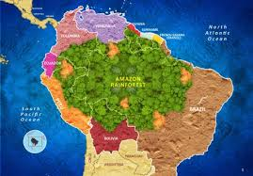
- deforestation,
- layers of the rainforest,
- animals and plants in the rainforest,

DO NOT start the non-chronological report at home, we will be doing this AT SCHOOL. ONLY do the research.

Remember we are happy for the children to magpie, but we don’t want a copy of the complete text.

OPAL – We Need You!

Our children love OPAL play at lunchtime. We now have a mud kitchen / café, willow arch, willow dome, den building and tyre play to name just a few things.

Our next project is to build a large sandpit for the children to play in. Mrs Rose has kindly offered to dig this out for us, but we will need parental help with the final set up. We are asking any parents available on Saturday 6th June to come to school from 9am-12pm to help us with some OPAL projects.

Our projects include:
- Lining the sandpit
- Filling the sandpit with sand
- Painting the storage sheds
- Planting up the tyres
- Creating play spaces for the children out of pallets

We kindly ask that you do not bring children to school for this session due to the tools and equipment that will be on site. If you are able to help us out, please email Mrs Vardy (lvardy@thomasrussell-junior.staffs.sch.uk) so that we can send out further information.

Dear Parent/ Carer

Over the next few weeks, the Year 4 English topic focuses on The Amazon Rainforest.

Having visited the zoo, begun to investigate the book ‘ The Greak Kapok Tree’, and learnt about some parts of the Amazon Rainforest in Geography, we have some exciting news!

We are having a Zoom call from author Ellie Jackson on Monday 27th April and we are giving children the opportunity to buy her books.

Ellie has written several books which focus on true and gentle stories about plastic pollution, climate change, litter and habitat loss.

When reading her books, children get to meet the characters of the Wild Tribe Heroes series, as they each face challenges in their natural habitats. Through their adventures, they discover the dangers in our world and how it affects their lives.

The Wild Tribe Heroes books are more than just great stories – they gently deliver important messages about protecting the environment. Both children and adults will love these inspiring tales and be motivated to make positive changes in their own lives and communities.

Ellie’s full collection of 7 books will be available at a special price of £5 each and she can sign and dedicate each copy. Plus, each child who orders a book will receive a free bookmark and postcard - a wonderful keepsake!

If you would like to order any of her books, please complete the form below detailing your preferences and then pay for them via parent pay. Closing date is Friday 15th May. Find out more about the books at www.wildtribeheroes.com

Kind regards

Year 4 Team
_______________________________________________________________________________

Child’s Name _____________________________

Books I would like to buy:

Title of book | I would like it signed (tick) | Dedicated message in the book(s) | I don’t want anything in the book.

I have ordered _______________ books and have paid ____________________on parent pay.

Signed______________________________ Parent/ carer

QR link to Ellie Jackson’s website. Find out more here.



Please see the letter below to order books. Thanks

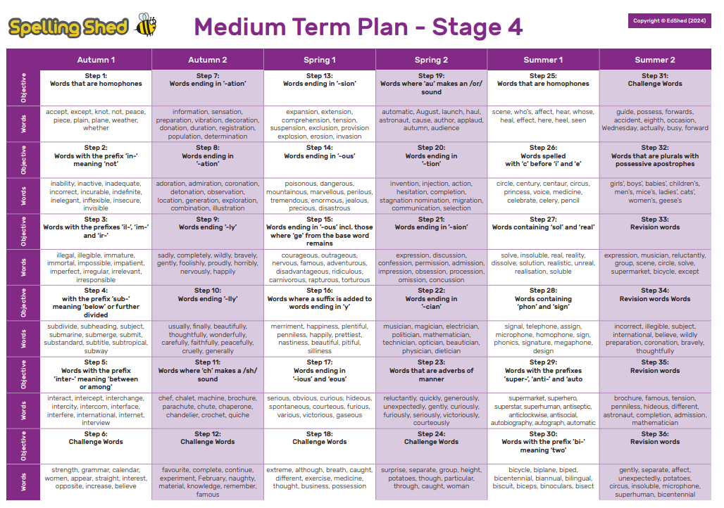

Dear Parent/Carer,

As you may know, the Multiplication Tables Check for year 4 children is happening between Monday 1st June and Friday 12th June 2026.
What is the Multiplication Tables Check?
- The checks consist of 25 times tables questions. The questions will only be multiplication and they will go up to 12×12. There’s nothing novel about the questions and they don’t require problem solving so there’s nothing to trip them up.
- There will be 6 seconds to answer each question.
- The check will be taken online during school time.
- There is no pass mark.
- Teachers will be able to apply for some children to be able to pause between questions.
Why do the children need to take this test?
All year 4 pupils in England will take the check. The Government made the check compulsory in 2022. They say:
The purpose of the MTC is to determine whether pupils can recall their times tables fluently, which is essential for future success in mathematics. It will help schools to identify pupils who have not yet mastered their times tables, so that additional support can be provided.
But why are times tables so important? Having rapid recall of times tables makes other areas of maths much easier. Fractions is the most obvious area where learning times tables well is essential. However, every multiplication, division, long multiplication method and short division and long division method require speed and instant recall of times tables while at primary school. At secondary school the needs become even greater.
Furthermore, having the tables secure frees up their working memory for newer, more challenging tasks at hand.
So learning them now, in year 4, sets children up for a more successful maths career later in their school life.
What can you do to help your child learn their times tables?
Attached to this letter is your child’s heatmap (which can also be accessed by logging in to your child’s account> Stats> Fluency). It shows their current recall time for each of the times tables facts. The greener the fact, the quicker the response time. Any facts shown in red or orange are slower than 5 seconds, and should be practised.
Spend some time with your child identifying which tables they need to practise, and celebrating the ones they already know.
Needs more practice

Getting there
Secure

How can you help them improve their recall times?
There are lots of ways to learn times tables, but here are a few suggestions to get you started:
- Make sure they play daily in Garage mode on Times Tables Rocks Stars - The Garage game mode is very clever and will adjust the questions your child is asked, ensuring they are always working on the facts they need to improve. Also, give them a times tables square to use whilst they play. This way they can double-check facts they are not sure about
- Sing times tables songs. There are hundreds available! Put them on in the car, bathtime or any ‘free’ time where you have a few spare minutes.
- Chanting the old-fashioned way- rehearse the tables forwards and backwards, gradually increasing in speed.
- Plenty of praise- When encouraging children to pursue something important, like timetables, there’s no harm in heightening their enthusiasm with plenty of praise. ‘You got this!’ ‘Look at your heatmap now!’
- Write out the tables – This can be in the form of a simple list or you could also be a bit more fun. Being creative will make writing and learning the tables more enjoyable.
  - Write the facts as the petals of a flower;
  - Get them to test you on the facts and get them wrong on purpose and see if they correct you!
  - Treasure Hunt: Hide the facts around the house and give them the answers. Can they find them in record time?
  - Take a pot of water and a paintbrush outside to ‘paint’ the facts on a wall.
  - Use chalks to write the facts outside in giant numbers.

Times tables are important, but it should be an enjoyable experience learning them!

