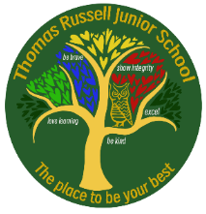
Week 19: Friday 12th June 2026
Have you completed your homework?

Weekly checklist:

Times Tables:
Please see the letter at the bottom of the sheet which informs you about the MTC check and how to support your family.

Reading:
Read five times per week (at least 2 of those to be your reading scheme book) and record it in your reading diary. An adult should sign each entry. Practise reading aloud as well as reading independently (silently). Reading Records will be collected in on Monday.

Reading Plus
Work hard to try and complete your x5 sessions.
We do complete Reading Plus for 15 minutes every afternoon, but please note that this doesn’t mean you don’t have to do any at home. If you haven’t managed your 5 reads in school this needs to be completed at home. If you want to do more - that’s excellent.
We are aiming for 80% or more comprehension success.

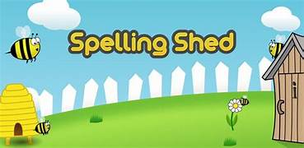
Spellings: Please refer to Medium Term Plan - Stage 4 page 4
This can be found on TRJS website: our learning: year 4 – 4th tab down titled spelling yearly overview – page 4.
Stage 34
Practise your spellings using the sheet and/or using EdShed.

MATHS: Assessment week

ENGLISH: Assessment week

LIBRARY VISIT MONDAY MORNING. Remember your coat and library card.

PLEASE REMEMBER TO BRING IN HEADPHONES FOR FRIDAY’S SPELLING LESSONS.


OPAL STAY AND PLAY
Parents and carers from Y3-5 are warmly invited to visit TRJS on Monday 15th June to join us for an OPAL play session.

- Find out all about OPAL play and why we do it here at TRJS.
- Join in with a session with the children.

Session Timetable
1:15pm Introduction to OPAL play.
1:50pm Play session with the children outside.
2:30-2:45pm Time to ask any questions and depart.

Please dress appropriately for being outside in all weathers and on the field!



