

Thomas Russell Junior School
Anti-Bullying Policy

Date policy approved: March 2026
Date for Review: March 2027

Introduction
The Anti-bullying Policy can be read in conjunction with: Positive Behaviour Policy; Attendance (pupils) Policy; Safeguarding and Child-on-Child Abuse Policies; SEND Policy; Acceptable Use and Online Safety Policies; RSHE Policy.

We use the Anti-Bullying Alliance (ABA) definition of bullying (see Appendix 1) as:
‘The repetitive, intentional hurting of one person or group by another person or group, where the relationship involves an imbalance of power. Bullying can be physical, verbal or psychological. It can happen face-to-face or online’.

Bullying is wrong and damages individual children. We therefore do all we can to prevent it, by developing a school ethos where bullying is regarded as unacceptable. We aim to produce a safe and secure environment where all can learn without anxiety. This policy aims to produce a consistent school response to any bullying incidents that may occur. We aim to make all those connected with the school aware of our opposition to bullying, and we make clear each person’s responsibilities with regard to the eradication of bullying in our school. We were accredited with the ABA’s United Against Bullying scheme Bronze Award in 2022-23 and Silver Award in 2023-24.

We are aware that some pupils are more at risk of being bullied than others due to their individual characteristics, relationships and the community. We are committed to preventing and responding effectively to the bullying of protected and vulnerable groups of children including disabled children / children with SEN, those who are or perceived to be LGBT, race and religion targeted, young carers, looked after children, appearance targeted, sexist and sexual bullying (see Equality Act 2010).

We understand bullying as a group activity (see Appendix 2):
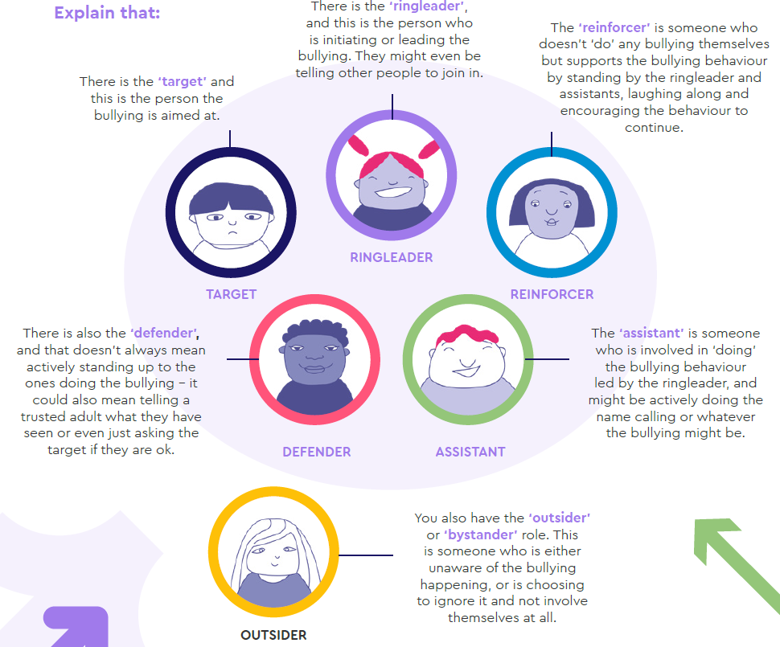

Responsibilities
The school’s RE-PSHE Lead coordinates our whole-school approach to anti-bullying. This person is Miss Claire Branson. The school’s Link Governor for RE-PSHE leads on anti-bullying activity and monitors school action in this area. This person is Mrs Elaine Watling.

Governors
The governing body supports the headteacher in all attempts to eliminate bullying from our school. The governing body seeks to prevent bullying from taking place in the school and seeks to ensure that any incidents of bullying that do occur are taken very seriously and dealt with appropriately. The governing body monitors the incidents of bullying that occur and reviews the effectiveness of the school policy regularly. The governors require the headteacher to keep accurate records of all incidents of bullying and to report to the governors on request about the effectiveness of school anti-bullying strategies. The governing body responds within ten days to any request from a parent to investigate incidents of bullying. In all cases, the governing body notifies the headteacher and asks them to conduct an investigation into the case and to report back to a representative of the governing body.

Headteacher
It is the responsibility of the headteacher to implement the school anti-bullying strategy and to ensure that all staff (both teaching and non-teaching) are aware of the school policy and know how to deal with incidents of bullying. This is also included at staff induction. The headteacher ensures that all children know that bullying is wrong, and that it is unacceptable behaviour in this school. The headteacher draws the attention of children to this fact at suitable moments. The headteacher ensures that all staff receive sufficient training to be equipped to deal with all incidents of bullying. The headteacher sets the school climate of mutual support and praise for success, so making bullying less likely. When children feel they are important and belong to a friendly and welcoming school, bullying is far less likely to be part of their behaviour.

Headteachers have the legal power to make sure pupils behave outside of school premises. This includes bullying that happens anywhere off the school premises, for example on public transport or in a town centre. School staff can also choose to report bullying to the police or local council. The legislation to support this can be found at https://www.gov.uk/bullying-at-school/bullying-outsideschool and https://www.legislation.gov.uk/ukpga/2006/40/section/89.
Teachers
Most importantly, teachers attempt to support all children in their class and to establish a climate of trust and respect for all. By praising, rewarding and celebrating the success of all children, we aim to prevent incidents of bullying. Through PHSE and other curriculum teaching we educate the children about how to treat each other fairly and with respect, and also about the impact of bullying. In this way, we also aim to empower ‘outsiders’/’bystanders’ to become ‘defenders’ and support the target of bullying to speak out and report it to a trusted adult.

Teachers in our school take all forms of bullying seriously and intervene to prevent incidents from taking place. They keep their own records of all incidents that happen in their class and that they are aware of in the school. If teachers witness an act of bullying, they do all they can to support the child who is being bullied. If a child is being bullied over a period of time, then, after consultation with the headteacher, the teacher informs the child’s parents. We record all incidents of bullying that occur both in school and those out of school on the children’s way to or home from school (see Appendix 4). If an adult witnesses an act of bullying, this would be investigated and recorded.

Parents
Parents who are concerned that their child might be being bullied, or who suspect that their child may be involved in perpetrating bullying, should contact their child’s class teacher or our school’s Anti-Bullying Lead immediately. Parents have a responsibility to support the school’s anti-bullying policy and to actively encourage their child to be a positive member of the school.

Reponses to bullying (see Appendix 3 for How to Report Bullying and Appendix 4 for Bullying Log)
The ABA recommends an effective response is where:
- Children are believed when they tell an adult they are being bullied.
- Children are involved in the solution.
- Schools educate children and young people about why bullying hurts.
- The bullying stops. This is more important than who is right or wrong.

If teachers become aware of any bullying taking place between members of a class, they should deal with the issue immediately. This may involve support for the target, and restorative work with the child/children who have taken part in the bullying. Staff spend time talking to the children who have bullied: explaining why their actions were wrong, and endeavouring to help the child change their behaviour in future. The message should be: “You might not understand someone’s behaviour, some behaviours may irritate you, some may amuse you, but it is never an excuse to treat someone badly or socially exclude them.” Targets of bullying should never be made to feel that it is their fault or that they need to change or learn to tolerate the bullying.

If a child is repeatedly involved in bullying other children, the headteacher and the special needs co-ordinator (if applicable) is informed. The child’s parents are then invited into the school to discuss the situation. In more extreme cases, for example where these initial discussions have proven ineffective, the headteacher may contact external support agencies such as the social services.

Training
Staff can access to free ABA online training at https://anti-bullyingalliance.org.uk/tools-information/free-cpd-online-training and are encouraged to complete course 1 ‘What is Bullying?’ and 2 ‘Bullying and the Law’.

Monitoring and review
The RE-PSHE Action Plan includes a section on anti-bullying which is regularly reviewed and updated.
This policy is monitored on a regular basis by the headteacher, who reports to governors about the effectiveness of the policy on request. This anti-bullying policy is the governors’ responsibility and they review its effectiveness annually through discussion with the headteacher. Governors analyse information with regard to gender, age and ethnic background of all children involved in bullying incidents.

Appendix 1: Definition of Bullying
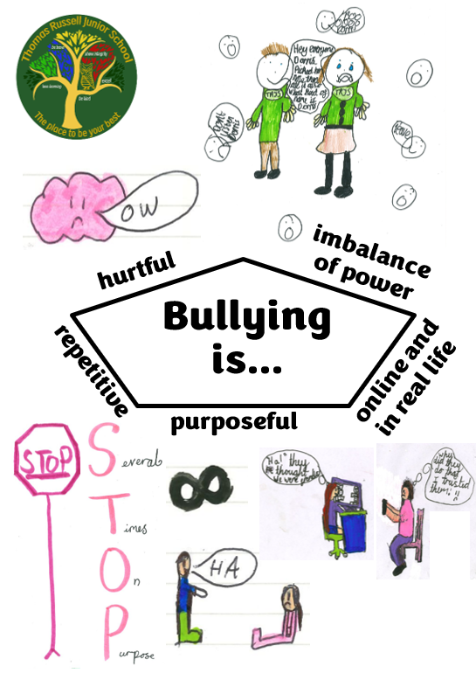
Appendix 2: Roles involved in bullying
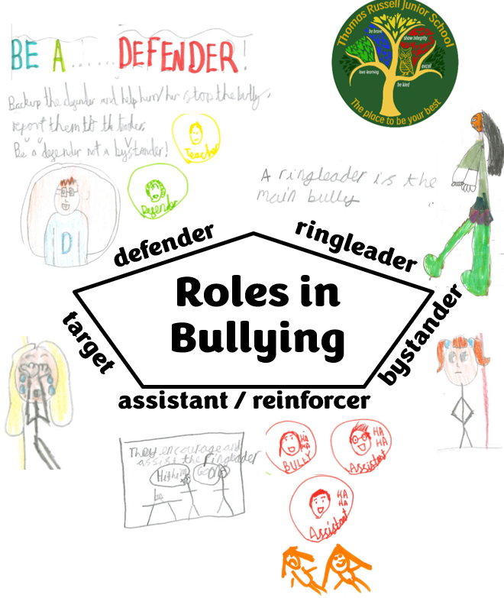
Appendix 3: How to Report Bullying

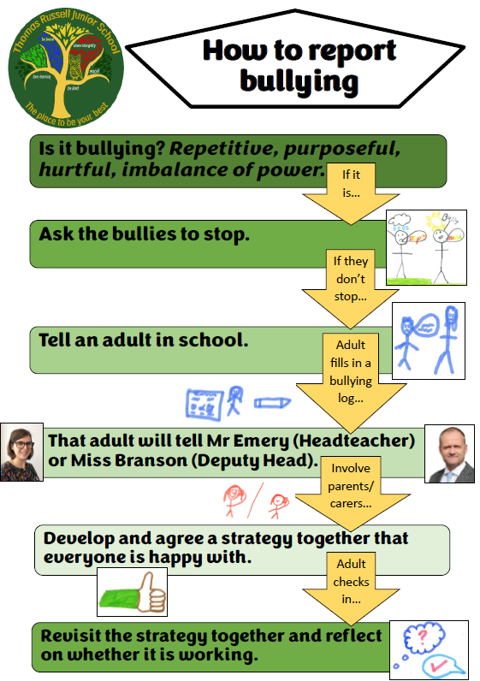
Appendix 4: Bullying Log
Thomas Russell Junior School
Bullying and Prejudice-Based Incident Log
Child’s name: |  | Class:
Date: |  | Time:
Name of member of staff reporting:
What happened?
- What type of bullying?
e.g. physical, verbal, property, psychological, online, manipulation, rumour spreading

- Who was involved?

- Where did it happen?

- When did it happen?

Was the bullying targeting any aspect of the child’s character? | - Race – racist bullying  - Culture  - Religion or faith  - Gender – sexist bullying  - LGBT+ - homophobic, biphobic or transphobic bullying |  | - SEN or Disability  - Appearance  - Health  - Related to home circumstances e.g. Looked After, Young Carer  - Other: _______________
How was the target (bullied child) affected at the time?
REMEMBER: Reassure the pupil/s being bullied that you are taking it seriously, it’s not their fault and they don’t have to put up with bullying.

- How did the child feel?

- What did they think should happen to make it right?

- Were there any injuries?

- Later effects

Did you access any external support? e.g. NHS, police |  |  |  | Yes / No
Is this a child protection issue? |  |  |  | Yes / No
Do you need to record an injury? |  |  |  | Yes / No
Please hand this form to the Anti-Bullying Lead (Miss Branson)
Review box: See below for ‘Roles involved in bullying’ record and review
- When will we review this?

- What have we learnt from this incident? What planning, support or guidance needs to be put in place to prevent future occurrences? e.g. learning on use of language, ethos, playground supervision, staff training needs, parental support

- Do any school polices or procedures need reviewing as a consequence?

Bullying as a group behaviour
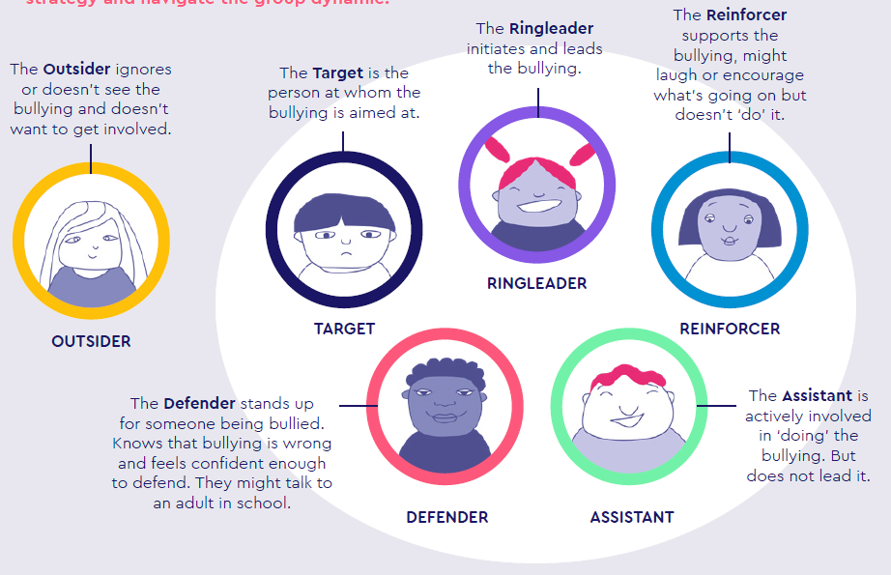
In the Anti-Bullying Alliance’s consultation with young people, they said that they preferred non-sanction-based responses to bullying.
Therefore, at TRJS we want to:
- Develop a strategy together with the Target/s that they are happy with.
- Be clear with the group that are bullying that their behaviour is not acceptable, and make them aware of any sanctions this behaviour has.
- Identify if the group that are bullying are aware about the impact of their behaviour for the target/s.
- Seek agreement in face-to-face conversation from all those involved about the way forward.
- Regularly check in with the target/s and make sure they have a discreet way to report to you about how they are feeling at school regularly.
- Involve parents/carers.
- Build our response on a restorative approach that changes the behaviour of the group and not solely focus on changing the behaviour of the target/s.

 | Name/s | How they were involved? | What could this group do to help stop the bullying?  E.g. stop the reinforcers laughing or create defenders | Agreement:  what approach  have you agreed to take with each group? | Review:  What strategies did you use, and did they work?
Target/s
Ringleader/s
Reinforcer/s
Assistant/s
Defender/s
Outsider/s
(key pupils who could potentially have a positive impact)
‘Roles involved in bullying’ Record and Review

