Thomas Russell Junior School
Job Role: Lunchtime Supervisor
6.25 Hours per week
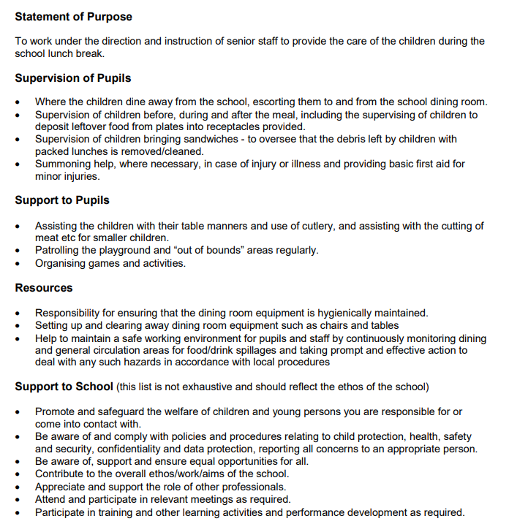

September 2026

