Y6 Homework – w.c. 21.09.26
Reading: Complete your 20 minutes a day, five times per week reading (at least 3 of those to be your reading scheme book) and record it in your reading diary. Make sure you ask an adult to sign each entry and remember to practise reading aloud (this could be an adult/pet/toy) as well as reading independently (silently). Hand it in next Wednesday (24th September).

Reading Plus: Complete x3 sessions (at least x2 will be completed at school). These can count as part of your 5 reads above. Record them in your reading record. We are aiming to achieve a reading speed of 185 words per minute and an 80% comprehension average.
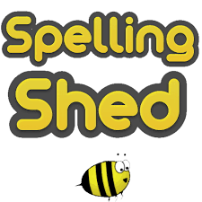
Spellings: Log-on to Spelling Shed to practise this week’s new list of words, which all have a /shul/ sound spelled -cial (after a vowel).
Please note: some children may have individualised (different) spellings they are working on instead. Your spelling pattern and words to practice for the week will show when you sign-in to Spelling Shed - /j/ sound spelled ‘g’.
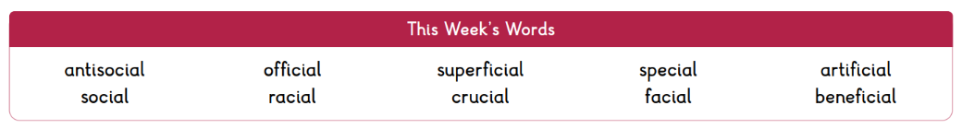


Maths: Times tables play a vital part in numeracy and mental arithmetic. Please complete 30 minutes of Times Tables Rockstars per week. Children know which times tables they will be tested on next week.
History: This half term we are learning about the Vikings. There is a list of books including fiction and non-fiction uploaded to the website that you may wish to explore to further your knowledge of this period of time.

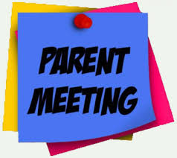
Y6 Parent Meeting: The Y6 team have organised a welcome meeting for all Y6 parents on Monday 28th September at 6pm. This will be an opportunity to meet the staff and find out about the expectations of Y6 including SATs, residential and preparation for high school.
The meeting is for parents/carers only as any relevant information will be shared with the children throughout the year.
Next Week’s Learning:
- English – we will be continuing to read and discuss our new text, ‘The Promise’, identifying character traits and demonstrating understanding by writing in role.
- Maths – Continuing to learn about factors and multiples as well as divisibility rules.

Contact: Please find below the email addresses for Y6 teaching staff should you need to contact us. We will endeavour to reply to emails within two working days, if it is urgent please contact the office.
cmurfin@thomasrussell-junior.staffs.sch.uk
cmarston@thomasrussell-junior.staffs.sch.uk

