Y6 Homework – w.c. 05.10.26
Reading: Read for 20 minutes a day, five times per week (at least 2-3 of those to be your reading scheme book) and record it in your reading diary. An adult should sign each entry. Practise reading aloud as well as reading independently (silently). Reading Records will be collected in on Wednesday 14th October.

Reading Plus: Please ensure all x5 of your assignments have been completed (at least x2 will be completed at school). These can count as part of your 5 reads above. Record them in your reading record. We are aiming to achieve a reading speed of 185 words per minute and an 80% comprehension average.
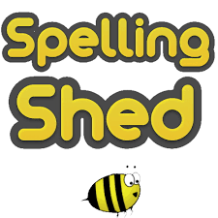
Spellings: Log-on to Spelling Shed to practise our new set of ten challenge words from the Y5/6 statutory word list. These will be tested on Friday 16th October. Usernames and passwords are in reading records.

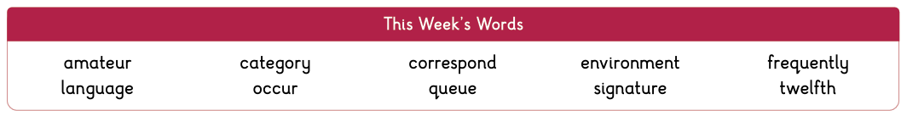


Maths: Times tables play a vital part in numeracy and mental arithmetic. Please complete 30 minutes of Times Tables Rockstars per week. Children know which times tables they will be tested on next week.


Next Week’s Learning:
Next week, we will be completing our first set of assessment papers. Please do not panic or worry about these! They merely provide a chance for us to practise assessment style questions and to identify areas of strength/improvement, so we can target our teaching next half term. A positive mindset is key – remember you have completed very similar assessment papers all the way through school from Y3 so let’s be resilient. You can do it!
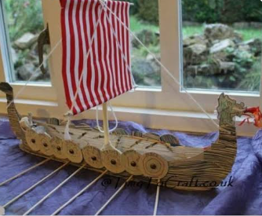
- Design Technology – On Friday 16th October, we will be making our Viking longboats. Please save any cardboard that you have at home for your child to bring into school on that day.


Contact: Please find below the email addresses for Y6 teaching staff should you need to contact us. We will endeavour to reply to emails within two working days, if it is urgent please contact the office.
cmurfin@thomasrussell-junior.staffs.sch.uk
cmarston@thomasrussell-junior.staffs.sch.uk
lvardy@thomasrussell-junior.staffs.sch.uk

