
Week 6: Friday 9th October 2026

This weekly sheet has everything you need to know about homework, key dates and what’s happening in Year 4. Please have a look through it each week so you know what’s coming up. Don’t forget to keep an eye on the newsletter too.

If you have any questions, please don’t hesitate to get in touch — our email addresses are
khiatt@thomasrussell-junior.staffs.sch.uk
ssmith@thomasrussell-junior.staffs.sch.uk
sakhtar@thomasrussell-junior.staffs.sch.uk

This week’s focus:
MATHS: addition and subtraction

ENGLISH: Adventure and Fantasy stories

Times Tables:
Please see the letter at the bottom of the sheet which informs you about the MTC check and how to support your family.

Reading:
Read five times per week (at least 2 of those to be your reading scheme book) and record it in your reading diary. An adult should sign each entry. Practise reading aloud as well as reading independently (silently). Reading Records will be collected in on Monday.

Reading Plus
Please do not access reading plus, we are waiting on the provider changing details for the new school year. We will let you know when it is up and running again.

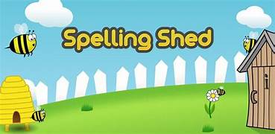
Spellings: Please refer to Medium Term Plan - below
We are focusing on Step 5

Practise your spellings using the sheet and/or using EdShed.

WOODLAND WARRIORS ‘BUGGINGHAM PALACE’.
As part of enhancing our school grounds and improving the diversity of plant and animal life, Year 4 children will have the chance to contribute towards a group project. Dr Veevers is going to work with each class to create “Buggingham Palace”: a deluxe bug hotel!
Please see the sheet below which tells you all about the sessions.

4S Tuesday 13th October

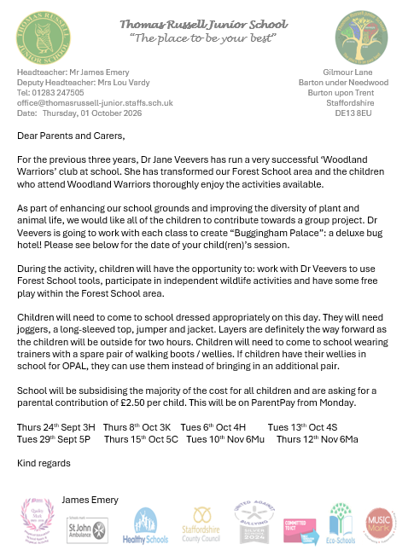

RUGBY
On a Monday afternoon, Year 4 children will be doing rugby in Games.
Mr Tolley will be teaching the lesson and children MUST have:
- a mouth guard, (we know it is short notice – please don’t worry if you aren’t able to get one this week as it is a tight turnaround from Friday to Monday).
- A change of footwear
- A bag to put their dirty football/ rugby/ trainers in after the lesson.

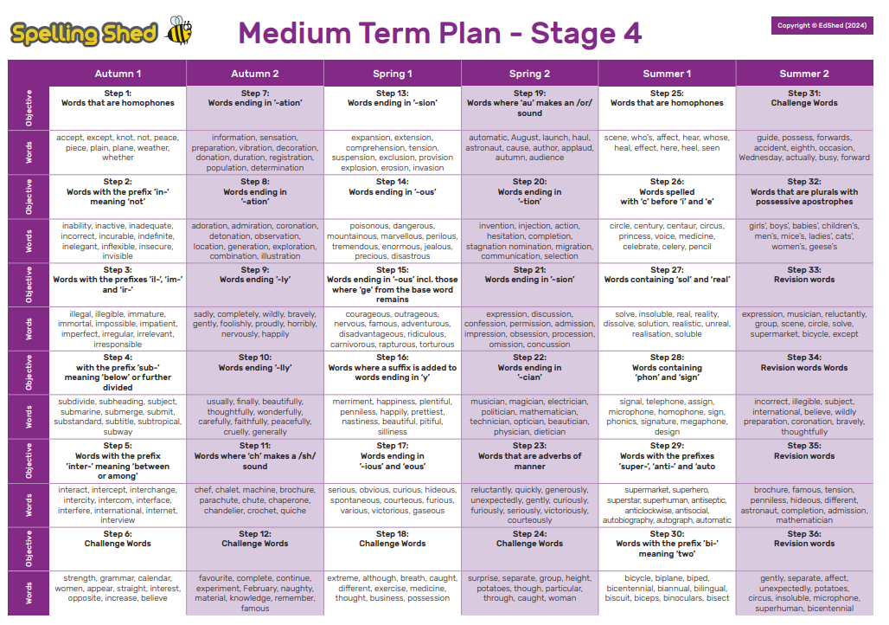



Dear Parent/Carer,

As you may know, the Multiplication Tables Check for year 4 children is happening between Monday 1st June and Friday 11th June 2027.

What is the Multiplication Tables Check?
● The checks consist of 25 times tables questions. The questions will only be multiplication and they will go up to 12×12. There’s nothing novel about the questions and they don’t require problem solving so there’s nothing to trip them up.
● There will be 6 seconds to answer each question.
● The check will be taken online during school time.
● There is no pass mark.
● Teachers will be able to apply for some children to be able to pause between questions.

Why do the children need to take this test?
All year 4 pupils in England will take the check. The Government made the check compulsory in 2022. They say:
The purpose of the MTC is to determine whether pupils can recall their times tables fluently, which is essential for future success in mathematics. It will help schools to identify pupils who have not yet mastered their times tables, so that additional support can be provided.

But why are times tables so important?
Having rapid recall of times tables makes other areas of maths much easier. Fractions is the most obvious area where learning times tables well is essential. However, every multiplication, division, long multiplication method and short division and long division method require speed and instant recall of times tables while at primary school. At secondary school the needs become even greater.
Furthermore, having the tables secure frees up their working memory for newer, more challenging tasks at hand.

So learning them now, in year 4, sets children up for a more successful maths career later in their school life.

What can you do to help your child learn their times tables?
Attached to this letter is your child’s heatmap (which can also be accessed by logging in to your child’s account> Stats> Fluency). It shows their current recall time for each of the times tables facts. The greener the fact, the quicker the response time. Any facts shown in red or orange are slower than 5 seconds, and should be practised.
Spend some time with your child identifying which tables they need to practise, and celebrating the ones they already know.

How can you help them improve their recall times?
There are lots of ways to learn times tables, but here are a few suggestions to get you started:
● Make sure they play daily in Garage mode on Times Tables Rocks Stars - The Garage game mode is very clever and will adjust the questions your child is asked, ensuring they are always working on the facts they need to improve. Also, give them a times tables square to use whilst they play. This way they can double-check facts they are not sure about
● Sing times tables songs. There are hundreds available! Put them on in the car, bathtime or any ‘free’ time where you have a few spare minutes.
● Chanting the old-fashioned way- rehearse the tables forwards and backwards, gradually increasing in speed.
● Plenty of praise- When encouraging children to pursue something important, like timetables, there’s no harm in heightening their enthusiasm with plenty of praise. ‘You got this!’ ‘Look at your heatmap now!’
● Write out the tables – This can be in the form of a simple list or you could also be a bit more fun. Being creative will make writing and learning the tables more enjoyable.
· Write the facts as the petals of a flower;
· Get them to test you on the facts and get them wrong on purpose and see if they correct you!
· Treasure Hunt: Hide the facts around the house and give them the answers. Can they find them in record time?
· Take a pot of water and a paintbrush outside to ‘paint’ the facts on a wall.
· Use chalks to write the facts outside in giant numbers.
Times tables are important, but it should be an enjoyable experience learning them!

