‘]/Y6 Homework – w.c. 12.10.26
Reading: Read for 20 minutes a day, five times per week (at least 2-3 of those to be your reading scheme book) and record it in your reading diary. An adult should sign each entry. Practise reading aloud as well as reading independently (silently). Reading Records will be collected in on Tuesday 20th October (a day earlier than normal due to residential).


Reading Plus: Ensure all your x5 reading assignments have been completed for the week (at least 2/3 will be completed at school). These can count as part of your 5 reads above. Record them in your reading record. We are aiming to achieve a reading speed of 185 words per minute and an 80% comprehension average.


Spellings: Step 7 – Challenge Words (set Fri 16th Oct)
Log-on to Spelling Shed to practise our new set of challenge words from the Y5/6 statutory word list. These will be tested on Friday 6th November (after half term due to residential). Usernames and passwords are stuck in reading records.
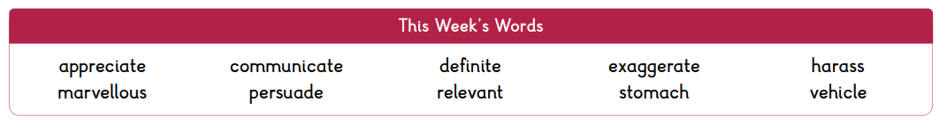


Maths: Times tables play a vital part in numeracy and mental arithmetic. Please complete 30 minutes of Times Tables Rockstars per week. Children know which times tables they will be tested on next week. When working on formal multiplication methods, we have noticed that some children have found this tricky because they are not confident with knowing all of the times tables facts up to 12x12. Please support your child in being able to recall any fact up to 12x12 within 5 seconds.


Next Week’s Learning:

- English – we will be revisiting some key spelling rules for plurals.
- Maths – we will be recapping written methods for division.
- Residential – use the kit list sent out to pack your bag ready for Whitemoor Lakes. Remember to bring a water bottle and packed lunch to take with you on Wednesday 21st October.


Contact: Please find below the email addresses for Y6 teaching staff should you need to contact us. We will endeavour to reply to emails within two working days. If it is urgent, please contact the school office directly on 01283 247505.
cmarston@thomasrussell-junior.staffs.sch.uk
cmurfin@thomasrussell-junior.staffs.sch.uk

