All about me – abstract art.
These are some examples of what your finished artwork could look like.
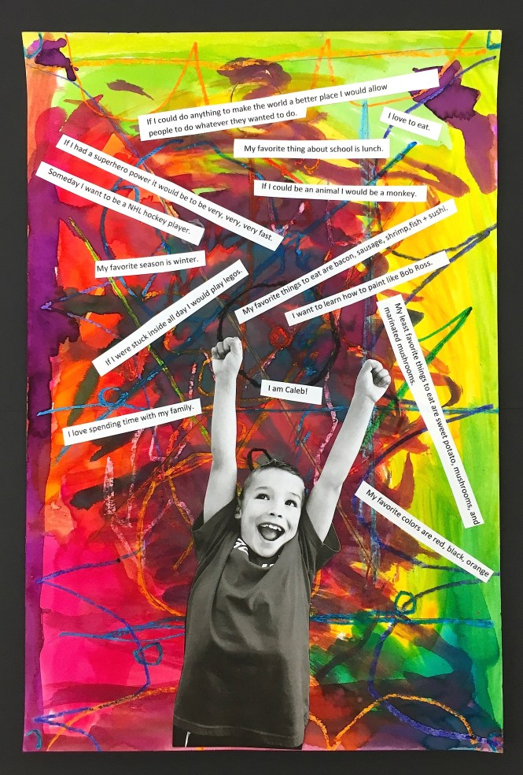
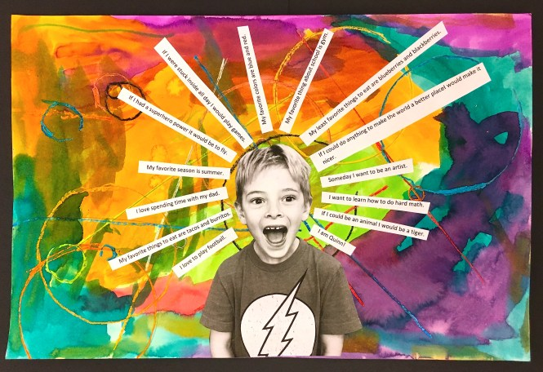

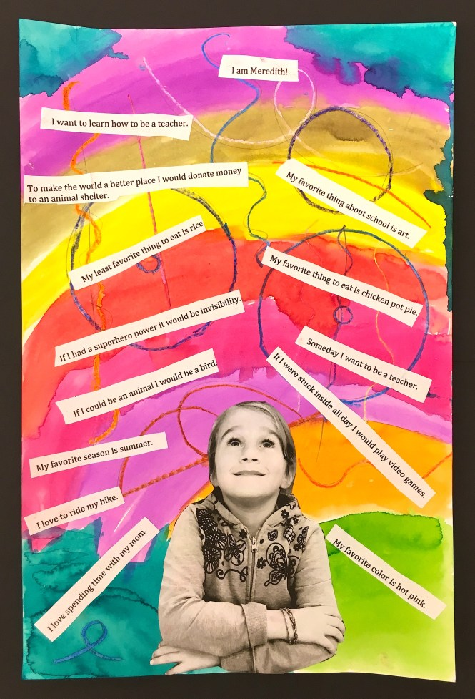

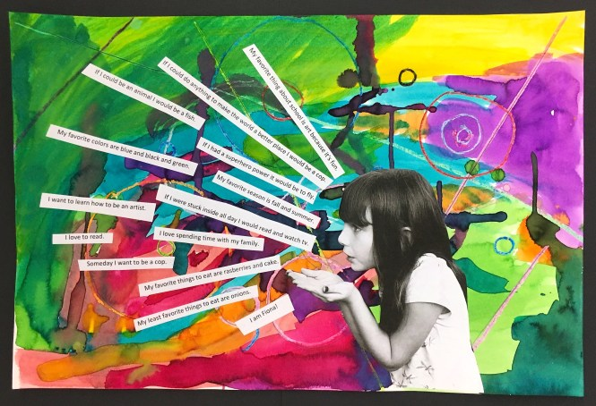

Instructions
Step 1. Draw an abstract drawing using various lines, and shapes on A4 paper. Then go over your lines with crayons - make sure to press hard. There is a PowerPoint presentation in the Daily Doodle folder if you would like to find out more about abstract art.
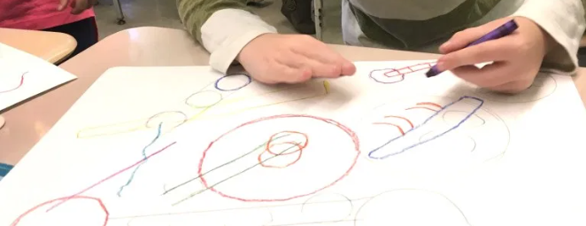

Step 2.
Paint your drawing using water colours. Try to keep it bright with a mix of colours – see the examples above.

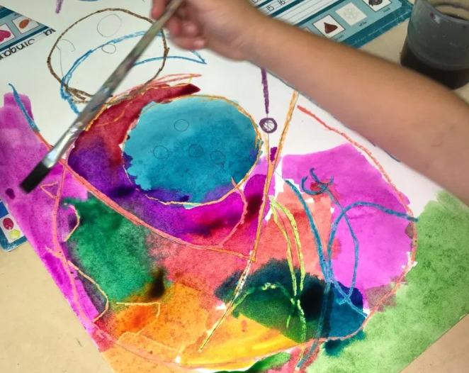

Step 3.
Answer each of the following questions. You need to write each answer as a full sentence.
We have written some sentence starters beneath the first few questions to get you started.

You can write or type your answers.

1. What is your name?
My name is….
2. What is your favourite subject?
My favourite subject is…
3. If you could have a superpower, what would it be?
If I could have a superpower, it would be…
4. What is a fun fact about you?
A fun fact about me is…
5. What is your favourite thing to eat?
6. If you could be an animal, what animal would you be?
7. What job do you want when you grow up?
8. What do you love to do? (you can have more than one answer for this one)
9. What is your favourite thing to do outside school?
10. What do you want to learn this year?
11. What are you most looking forward to when you join Y4?

Step 4.
Strike a pose! Stick a photograph onto your background (once it is dry!). A black and white photograph could look really good against the colourful background.

Then cut out your answers into strips and arrange around your photo.

