Thomas Russell Junior School

Friday 17th April 2020
9 – 9.30am | ‘PE with Joe’  Start the day with some action!  A 30 minute workout with Joe Wicks on YouTube.
9.30 – 11am | Another book that you may like to look at with an adult that deals with the Coronavirus can be found at issuu.com/nosycrow/docs/coronavirus_ins/1?ff&hideShareButton=true.  It has been illustrated by Axel Scheffler, who worked with Julia Donaldson on The Gruffalo and her many other famous books.
11.15 – 12.15pm | Our next TT Rockstars battle will be next week. Get those fast fingers and brilliant brains ready for the fight…!  This week, try another of the White Rose Easter Maths Challenges:  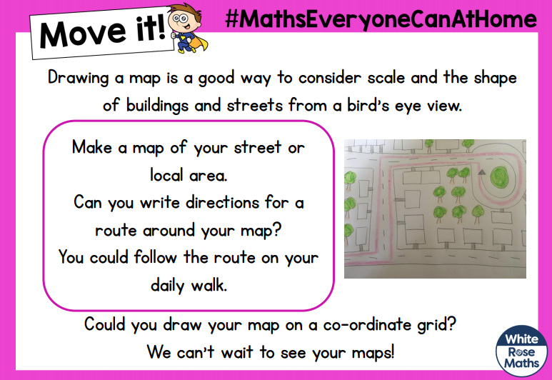
Lunchtime! | Enjoy some family time this lunch. Have a chat about your Easter holiday and the memories you have created together.
1.15 – 2.15pm | Take a virtual tour of the Natural History Museum by going to nhm.ac.uk/visit/virtual-museum.html. You can take a deep dive into the life of a blue whale, let Sir David Attenborough guide you round the displays, examine a 3D model of Dippy Diplodocus’s skull or be wowed by images from the Wildlife Photographer of the Year.
2.30 – 3.30pm | Get up and moving with Cosmic Kids Yoga, a mix of Yoga, mindfulness and relaxation designed especially for children. Go to youtube.com/user/CosmicKidsYoga and choose a video from the ‘older kids’ playlist. See who else you can encourage to join in with you!

