English
Monday L.O. Participate in presentations giving well-structured explanations.
Gain, maintain and monitor the interest of the listeners.

Starter: Go through the adverbs ppt and review how to use and identify adverbs.

Main Activity:

- Look at the worksheet Would you rather? (see resources). Read and talk about the questions with an adult if possible. Discuss the meaning of opinion and reasons (e.g. What’s your opinion? What are your reasons?)
- Look at Greatest Person Ever – Frame (see resources). Today you are going to explore another question about opinions and reasons. Read an example of The Greatest Person Ever (see resources). Identify some of the language features that you used in giving your opinion and your reasons e.g. rhetorical questions, emotive language – timeless, brilliant, memorable, appealing to the audience with imperative verbs – ‘Think how…’ Make a list of these features.
- Think about what you need to do to deliver the talk in an interesting way.

Independent Task:

Children begin to draft their own ‘Greatest Person ever’ piece of writing. Thinking about rhetorical questions, emotive language, modal verbs, subordinating conjunctions.

Red and Orange: Using the frame, children complete their talk on the greatest person ever, filling in the missing boxes.
Yellow: Children use the frame as a guide but write their talk independently thinking about using rhetorical questions, modal verbs and subordinating conjunctions to expand on ideas. Green/Purple: As yellow but encourage children to use a range of emotive language, and a range of punctuation (brackets/dashes.) Children use the giving your opinion starter cards to help with construction.

Tuesday L.O. Participate in presentations giving well-structured explanations.
Gain, maintain and monitor the interest of the listeners.

Starter: Prepositions. Go through the ppt to review what a preposition is and how to use it in a sentence.

Main Activity:

- Review the Greatest Person Ever speech example from yesterday, thinking about the features discussed. Look through your writing and think about what could be added today: Noun phrases, emotive language, rhetorical questions, modal verbs, parenthesis etc.

Independent Task:
Children complete the ‘Greatest Person ever’ piece of writing. Thinking about rhetorical questions, emotive language, modal verbs, subordinating conjunctions.

Red and Orange: Using the frame, children complete their talk on the greatest person ever, filling in the missing boxes.
Yellow: Children use the frame as a guide but write their talk independently thinking about using rhetorical questions, modal verbs and subordinating conjunctions to expand on ideas. Green/Purple: As yellow but encourage children to use a range of emotive language, and a range of punctuation (brackets/dashes.) Children use the giving your opinion starter cards to help with construction.

If possible, perform your completed speech to an adult at home.
Wednesday: Guided Reading

LO: To use Inference Iggy to support our reading.

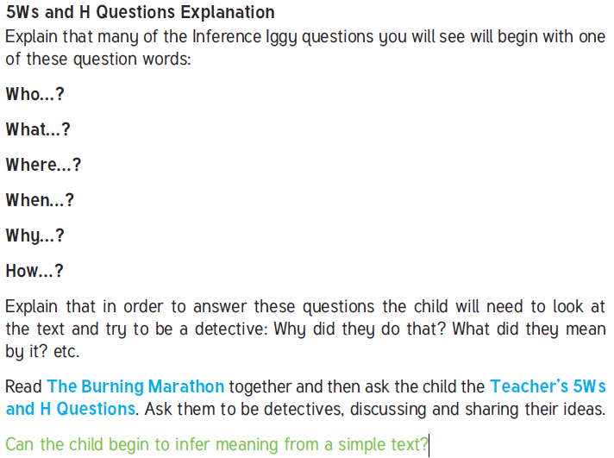

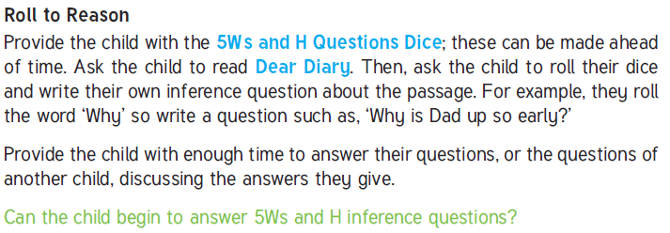

Wednesday L.O. Maintain attention and participate actively in collaborative conversations, staying on topic and initiating and responding to comments

Starter: Past and present perfect ppt. Go through the ppt and review how to construct the perfect tense.

Main Activity:

- Show children the front cover of The Steves by Morag Hood. Explain that this is a book for younger readers, but that it will be useful for our thinking. Enjoy reading the book together. https://www.youtube.com/watch?v=l1NjmCB2H_4 (watch from 2:17)
- Talk about the book with an adult. What opinion did each of the puffins have? (That they are ‘Steve’). What reasons did they give for their opinion? (Work through the book and talk about the reasons that they try to give and how effective these reasons are).
- Think about why the puffins end up arguing with one another when all they are doing is giving their opinion. On Day 1, we saw that opinions could be different and it didn’t matter. Why does it matter so much to the Steves? Help children to understand that in this case the opinion of each of the puffins affects the other.
- Understand that questions about opinions often affect other people. We call the people who are affected: ‘stakeholders’.
- Look at the Stakeholder Grid (see resources). Start to talk about who might be affected by each of these opinion questions.

Independent Activity:

Yellow: Complete the Stakeholder Grid. Think about, then write about who might be affected and how they might be affected.
Red and Orange: Use the Stakeholder Cards to cut out and place in the first three rows of the grid. They can then try adding to the second two rows themselves.
Green and Purple: Challenge children to think of 3-5 more opinion questions that might affect different stakeholders. They make a new grid to show their ideas.

Thursday: Guided Reading

LO: To use Inference Iggy to support our reading.

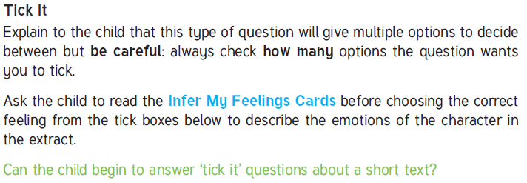
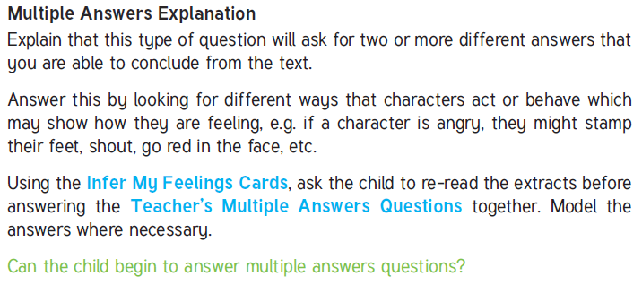

Thursday L.O. To write an argument to show why something should be banned.

Starter: Modal verbs. Go through the ppt and review modal verbs and how to use them.

Main Activity:

- Think about this question: If you could make any new school rule what would it be? Ask them to talk with a partner about their idea and then hear some of their ideas together.
- We are going to be thinking about the sort of rules that ban things. Look at the Should be banned - Frame (see resources). Follow through this frame whilst reading the Should be banned - Example).
- Think about whether banning things is a personal opinion or whether it affects other people (It affects others). Who do we need to think about then? (Stakeholders). Show how you thought about stakeholders in your argument, in the reasons that you gave for your change and in the section where you said ‘some people would argue that’.
- Look at the prepared notes for the talk Should be banned - Example (see resources). Use your list from Monday to look for language features, adding new features to your list.

Independent Activity:

- Children work to prepare a talk using Should be banned Frame – focus on the should homework be banned?

Red and Orange: Using the frame, children complete their talk homework being banned, filling in the missing boxes.
Yellow: Children use the twinkl frame as a guide but write their talk into their book thinking about using rhetorical questions, modal verbs and subordinating conjunctions to expand on ideas. Provide word list sheets to support construction.
Green/Purple: As yellow but encourage children to use a range of emotive language, and a range of punctuation (brackets/dashes). Children use the giving your opinion starter cards to help with construction. TA support. Push for varied openers, varied punctuation, semi-colon before a conjunction with purples.

Friday L.O. Creating nouns with the ‘ness’ suffix.

Main Activity:

Work through the ppt to introduce creating nouns with the suffix ness.

Independent Activity:

Children to complete the word web activity sheet.

