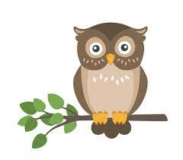

Set: Friday 14th January 2022 Due in: Thursday 20th January 2022

Spellings
The spelling words for the test are at the front of your homework book. Next week will the end of unit spelling test which is a test on the last 6 weeks spellings.

Times tables: The times table I am learning this week is x____ / ÷_____ / mixed _____

Library visit: On the 31st January, Year 3 have been invited to take a trip to our local library in Barton. We have sent out a library card form to all children this week so that if you do not already have a library card, you will be able to sign up for one. You can either return this form to the library directly or bring it in to school by the 25th and we will make sure that it makes its way there.
If you already have a library card, please bring it with you on the day.
During the visit, children will have the opportunity to browse the library books and select books that they wish to borrow and take home. If you have any library books at home that need returning, please feel free to bring these along with you and return them on the day.

Spag.com: Please complete the task set.

Outdoor Maths: We will be outdoors for maths on Wednesday. Please make sure you have appropriate layers of warm clothing and a change of foot wear in school on this day.

Next week
Maths: We will be focusing on mental multiplication and division next week using the 2,3,4,5,8 and 10 times tables. We will also be learning how to divide with remainders.

English: We will be continuing with our ‘fables’ topic. We will be using conjunctions to create compound sentences and will be using a story mountain to plan out the fable ‘The Lion and The Mouse.’

Spelling score Times tables score:

Parent’s comment

Teacher’s comment:

