Week Beginning: Monday 14th March 2022

READING:
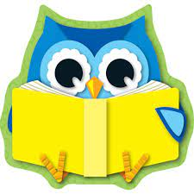
20 minutes a day. Please record the reading that you have done this week in your reading diary. Think about the different texts that you are reading, are you reading lots of different genre? E.g. poetry, stories, newspapers, magazines or classic stories. Are you reading stories by lots of different authors? E.g. David Walliams, Jeremy Strong, Michael Morpurgo or J K Rowling.

Read at least five times at home, to an adult. Please sign the reading record and hand in on Wednesdays.
Log in to READING PLUS (like we have been doing in our guided reading sessions in school) and work for 30 minutes.

ENGLISH: Complete the SPAG Retrieval Working Memory Challenge Grid – Types of Sentences for Wednesday 16th March.

SPELLINGS HOMEWORK Just to remind you that on Friday 18th March, your children will be tested on 10 words, which investigate the weekly spelling pattern and 10 words from the year 5 and 6 spelling list, which can be found in the front of the Homework book. These words will be chosen at random and scores noted for future use.

MATHS/ TIMESTABLES It is expected that children in Year 4 should know their 2-12 times tables as they play a vital part in numeracy and mental arithmetic. Please practise their times tables and try the online activities on MyMaths and TTRockstars.

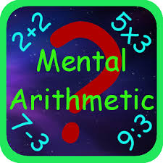
MATHS: This week’s homework is a mental arithmetic paper. Set a timer for 15 minutes and work carefully through the questions. After the timer has finished, please complete any unanswered questions in pink polishing pen. Hand in on Wednesday 16th March.

DON’T FORGET YOUR BOOKLET ON MONDAY 14TH MARCH SO THAT IT IS IN SCHOOL READY FOR TUESDAY’S LESSON.

Spelling score:

Times tables score:

Parent’s comment

Parent’s signature

Child’s comment

Teacher’s comment:

