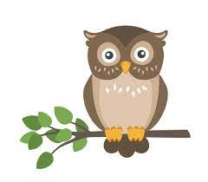
Week Beginning: Monday 24th March 2023
Reading: 20 minutes a day – this should include at least one Reading Plus reading and vocabulary lesson. Please record the reading that you have done this week in your reading diary. Reading records to be handed in on Wednesday for checking and rewards.

Spellings: Continue to use your Spelling Revision pack to revise: plural spelling rules, homophones, silent letter words, -ough words, adding prefixes (mis-, dis-, re-, im-, in-, un- etc), adding suffixes (-ful, -ness, -ment, -tion/-sion, -cious/-tious, -ible/-able, -ence/-ance etc). We have sent home your answer sheet from this week’s test to help you identify areas for improvement; use this to target specific prefixes/suffixes or spelling rules/patterns you are not yet secure with, rather than just practising the individual words you got wrong.
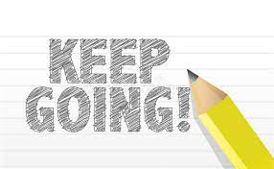
English: Try completing the Y6 Grammar Revision Tarsia Puzzle 1 – cut out all the triangular pieces then match up the sides with the grammatical terms written on them (in red) to their correct definition (in blue) – like a big jigsaw! There is a second blank version to try, where you have to write in your own definitions of each term, if you fancy a challenge instead!

Some extra SPAG.com activities have also been set to support your SPAG revision – YOU DO NOT NEED TO COMPLETE ALL OF THESE – they are simply there for those who want to brush up on some specific areas of our grammar learning or have a go at some SATs style some test practice!
This week we used some videos and songs to help us with our SPAG revision. The links are below (or zap the QR code for quick access) if you want to revisit them and explore new ones.
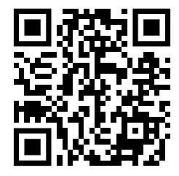
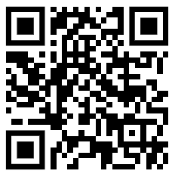
www.youtube.com/watch?v=T19g3E0ALqE
www.youtube.com/watch?v=wyyrs-hIDMc

Maths / Times Tables:
Please complete page 2 of the maths vocabulary sheet you were given last week. Fill in the missing information. If you are unsure of how to explain a term, try looking it up online with ‘key stage 2’ in your search. Please also complete the 10-minute SATs buster sheet. Remember to bring the sheets to school on Wednesday 3rd May ready for marking.

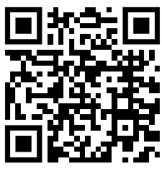
Art: This week we created templates for tessellating patterns. Lots of you enjoyed this, so the video link is below in case you wanted to continue with this at home. www.youtube.com/watch?v=Lc4LGZwlcvs

Spelling score:

Times tables score:

Parent’s comment

Parent’s signature

Child’s comment

Teacher’s comment:

